**BOOK ROOMS**

1. After the customer clicks on the dark blue Book Now button, the customer sees a calendar with a form on the left side of it. In the form, the actor chooses the check-in date and check-out date. Input the number of people (adults and children) and the promo code on the right.

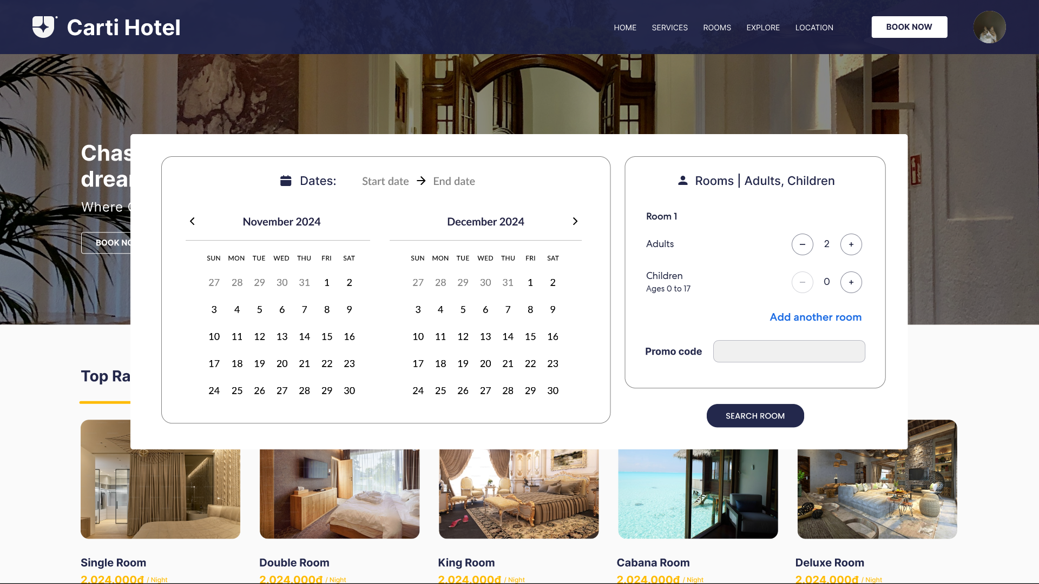

1. After that, the actor clicks on the dark blue Search Room button and the page is reloaded. The list of suitable rooms will display, the description will be displayed right in each room with number of people and total price. Customer can choose the room which he/she want by clicking the dark blue “Select” button.

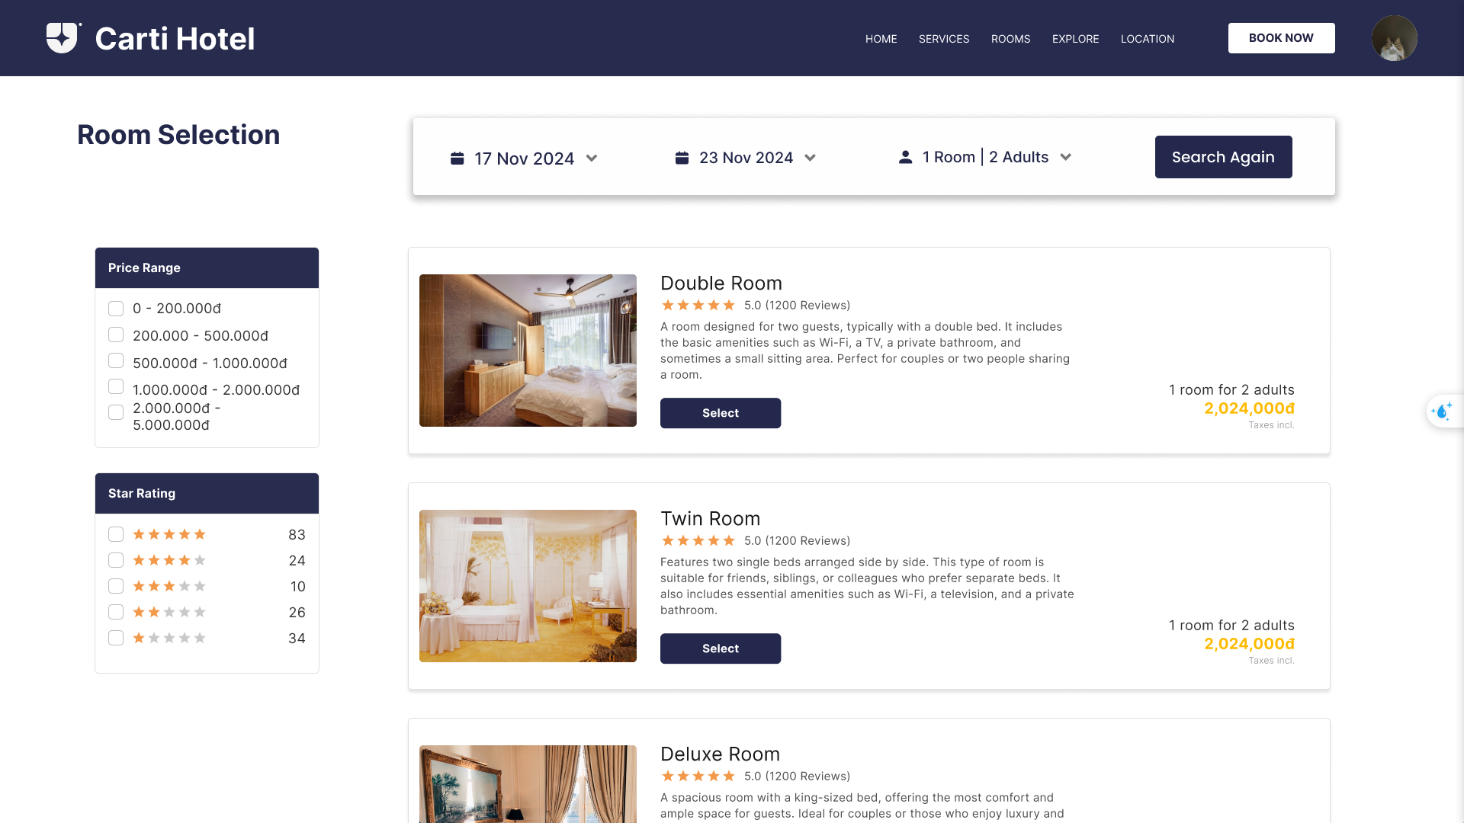

1. The page updates to display detailed booking information in a rectangular box, including the address, reception opening hours, check-in and check-out dates, spoken languages, and contact information, detailed room descriptions and prices, followed by a form to input personal details such as email, title, first name, last name, phone number.

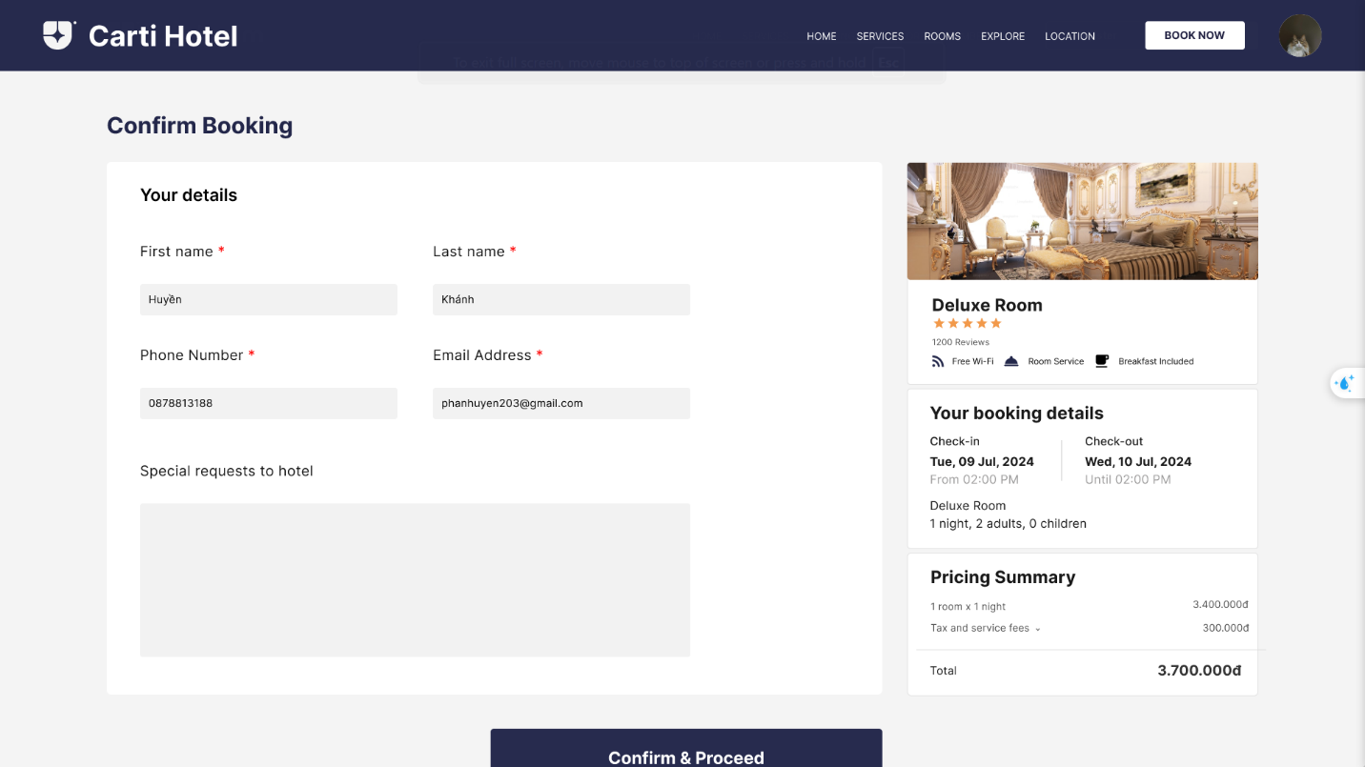

If the information customer enter are invalid, there is a rectangle pop-up notification, customer need enter valid information again.

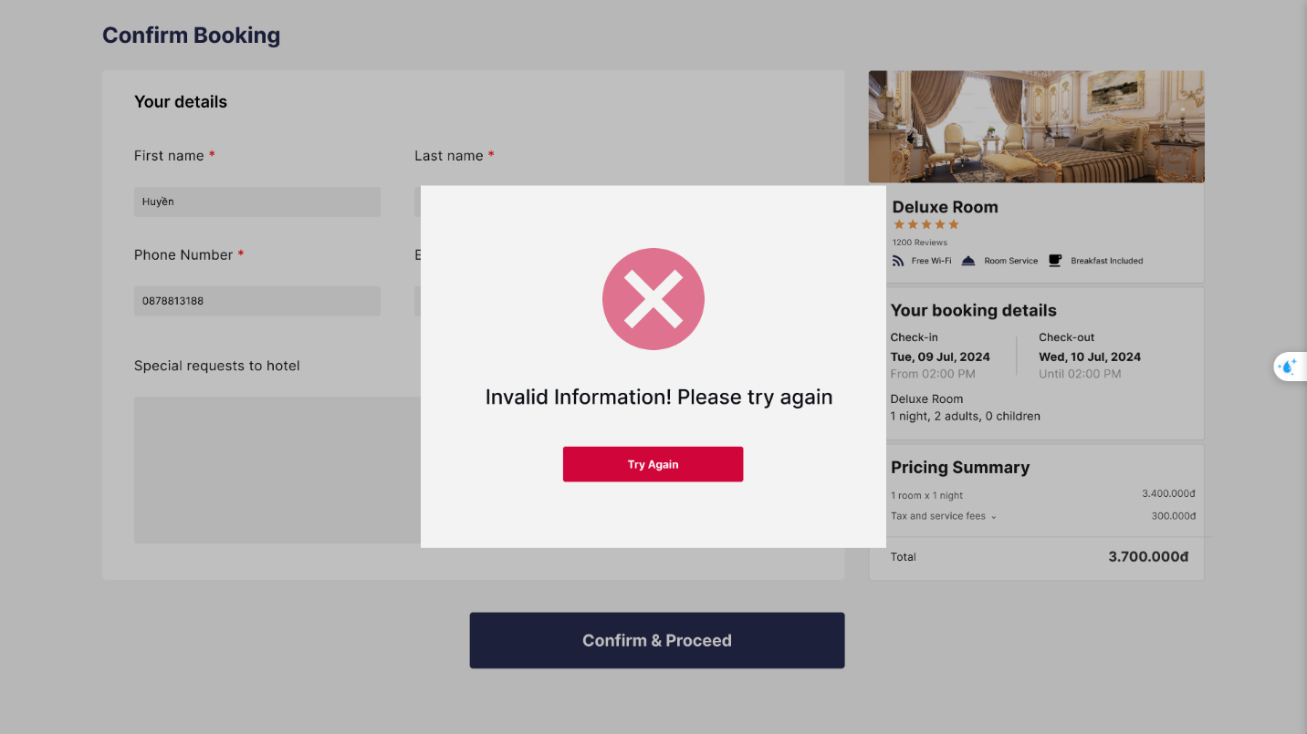

1. At the bottom of this page is a dark blue **Book&Proceed** button to confirm the reservation. If all information is valid, the customer is redirected to a confirmation page that displays a successful booking message with a reservation.

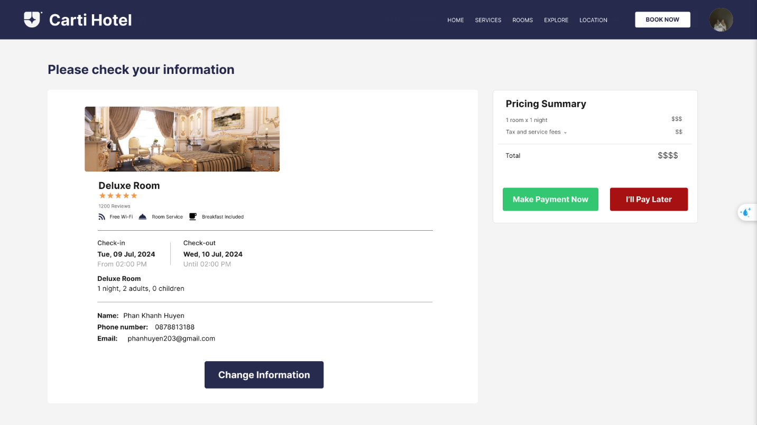

**CHECK OUT**

The workflow begins on the Receptionist Page, where the left panel displays functional buttons for key actions like Home, Reports, Check-in, Check-out, Manage Rooms, Manage Services, and Customers. The main section showcases the status of all rooms, color-coded for easy identification: green for "Vacant Ready," purple for "Being Cleaned," blue for "Stay Over," and grey for "Vacant Dirty."

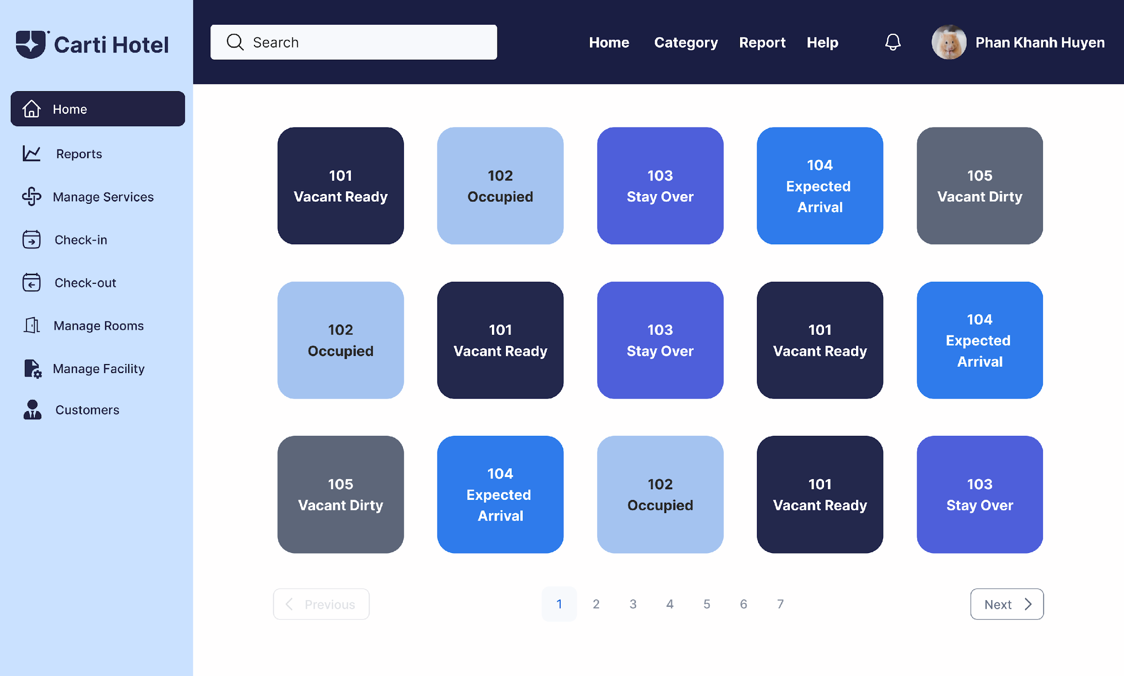

The receptionist starts by entering a customer’s name in the search bar located at the top of the page and clicking the Search button. The system retrieves and displays a dropdown list of matching customers.

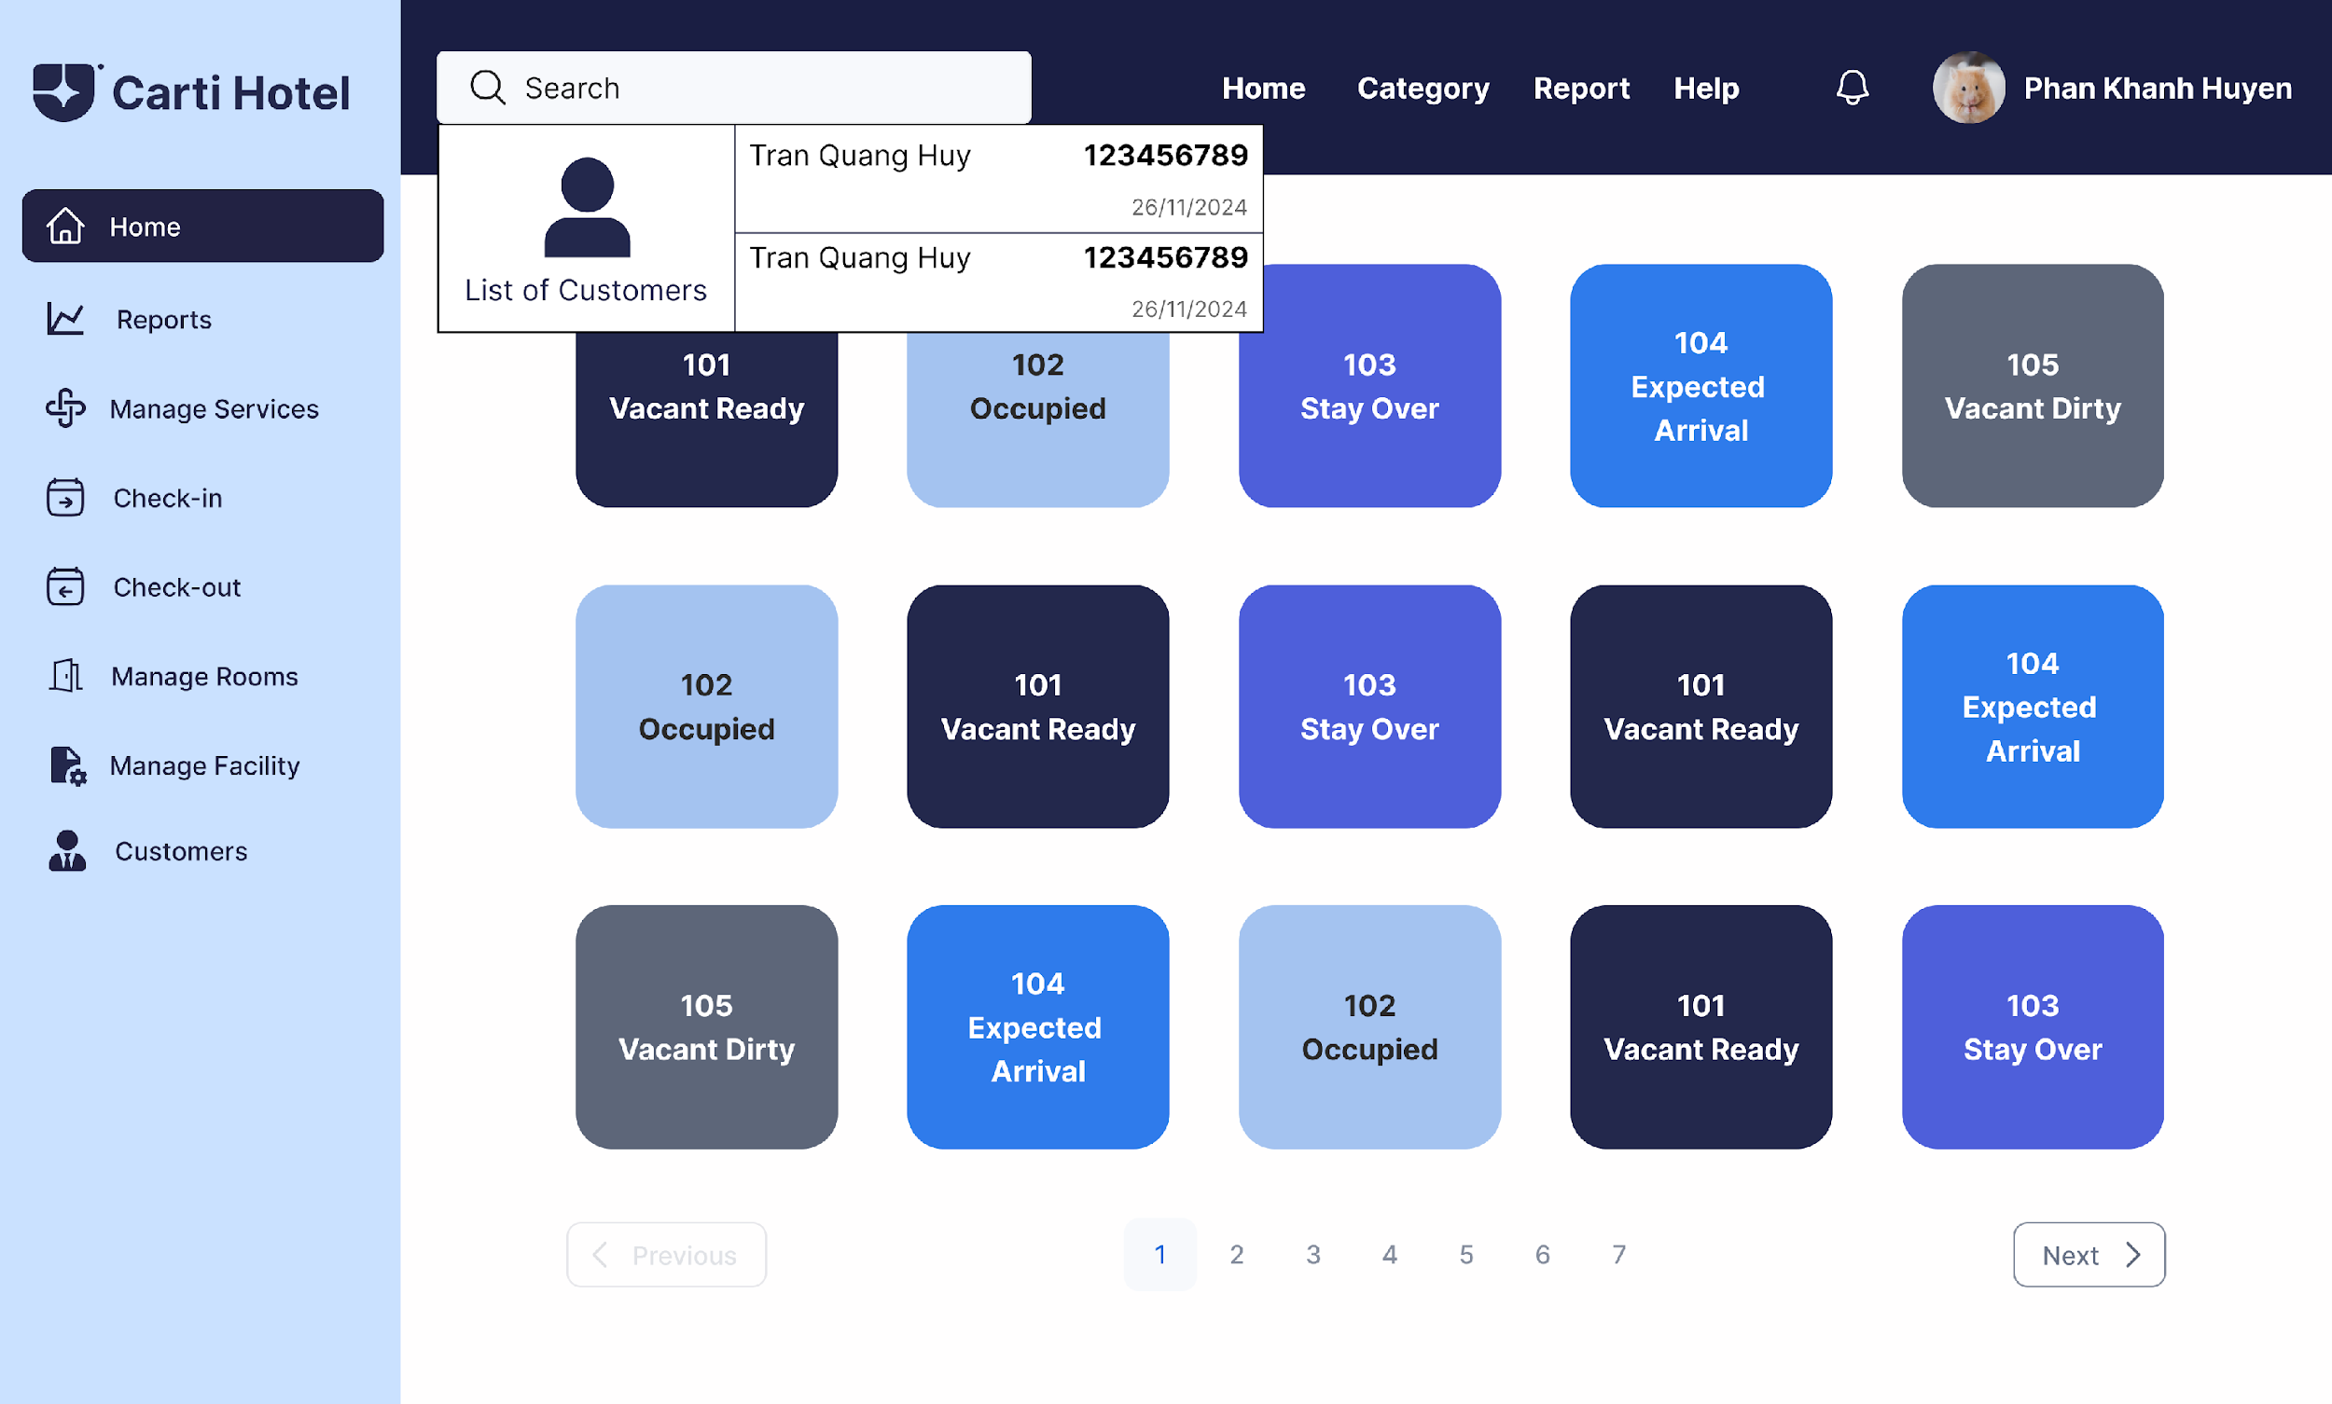

The receptionist selects a customer, navigating to the Reservation Page, which displays the customer’s reservation details in blocks. Each block contains information such as room type, check-in and check-out dates, total length of stay, and price.

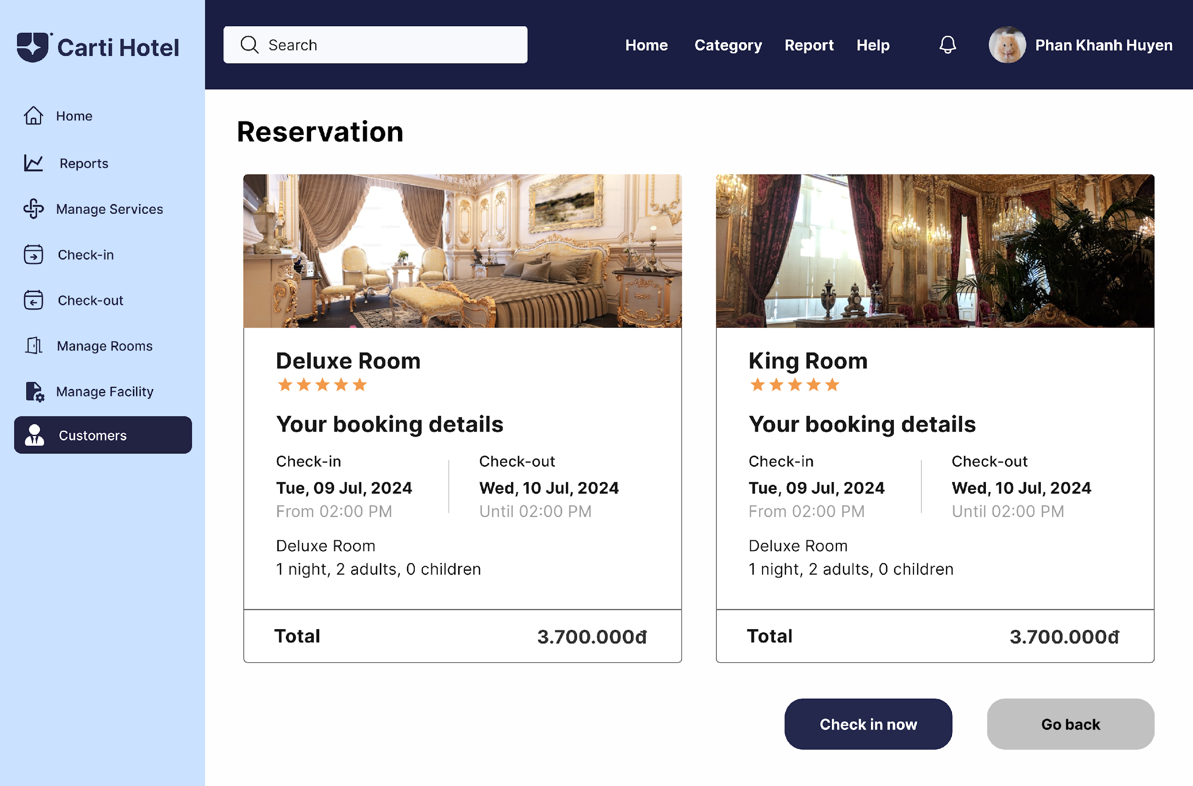

By clicking on a specific reservation, the receptionist is redirected to the Reservation Detail Page, where the bill is displayed in a detailed table format, including check-in and check-out dates, room charges, services used, and the total amount. Below the table, the Check-out Button is provided for finalizing the process.

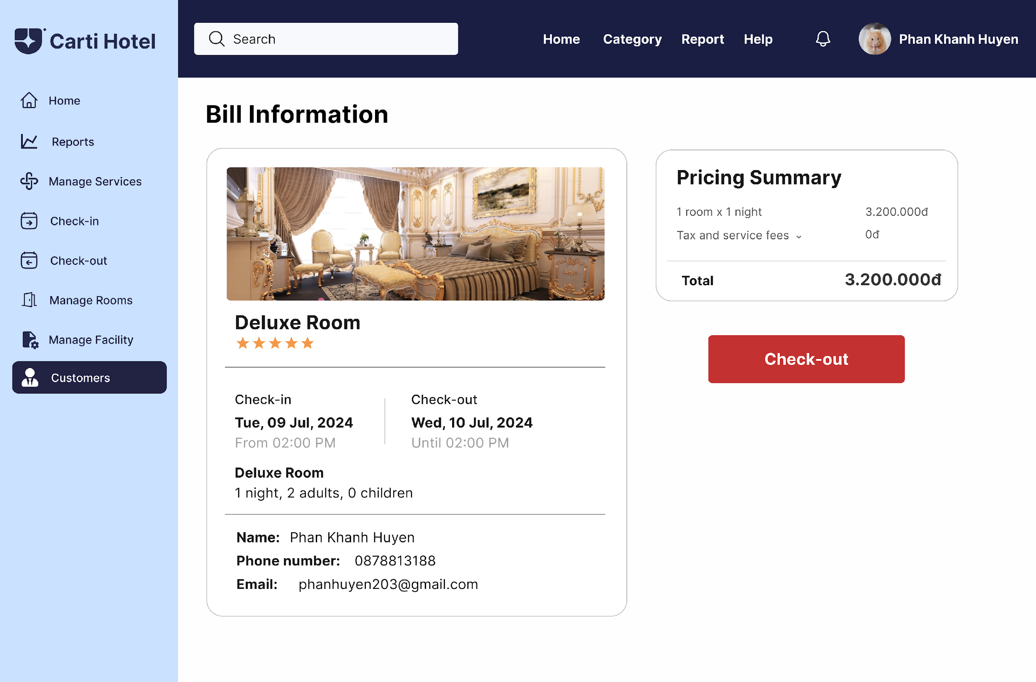

Upon clicking the Check-out Button, the system updates the room’s availability and the customer’s reservation status in the database. The receptionist is then redirected to the Bill Information Page, where additional options are available to Print Bill, Save Bill, or Export Bill. If needed, clicking the Print Bill button generates a physical copy of the final bill for the customer.

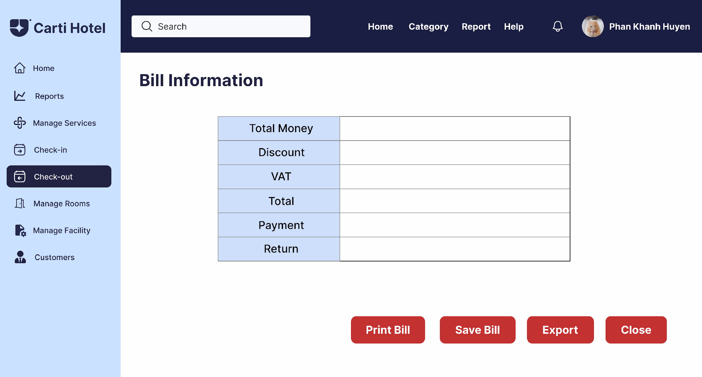

**CHECK IN**

Firstly, the receptionist enters the customer’s name on the search bar and then clicks the Search Button. A list of matching customers will be shown:

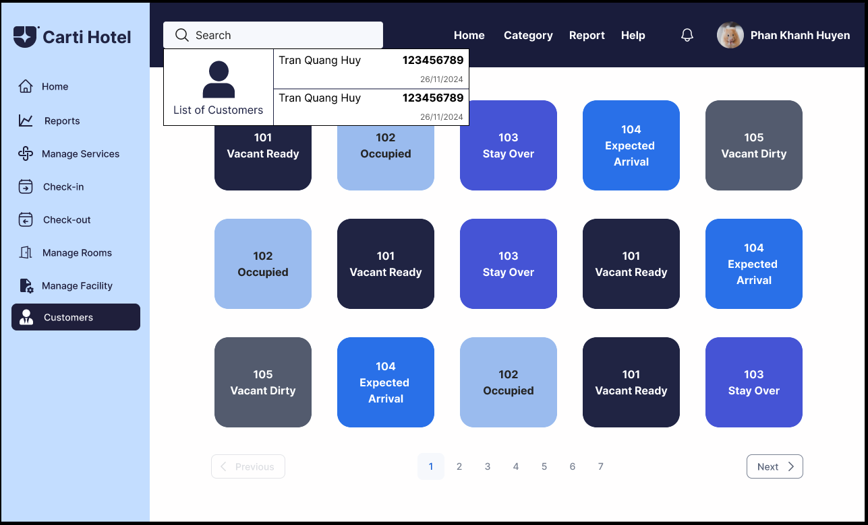

The receptionist clicks on a customer, then the reservation history of that customer will be shown up. Each block is a reservation including check-in, check-out date, total length of stay, the room type and total price. Below these blocks are two buttons: Check-in now to check-in for customers and Go back to come back.

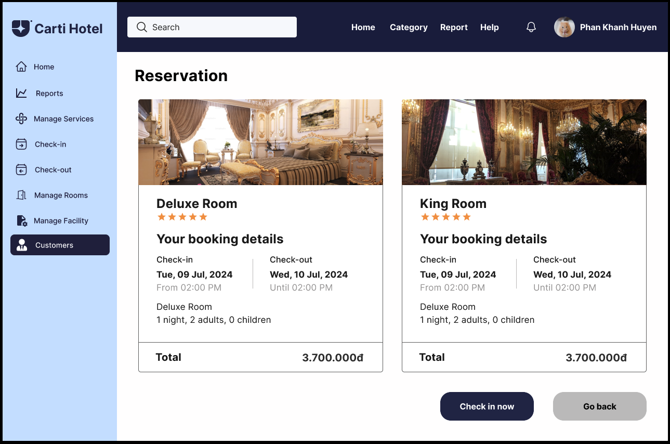

If the customer has booked any room in advance, the receptionist does not have to check-in for that customer anymore. Else, click on the Check In Now Button, which will navigate the receptionist to the Check-in Page. There, the receptionist chooses all the options that the customer requires. The chosen room will be blue.

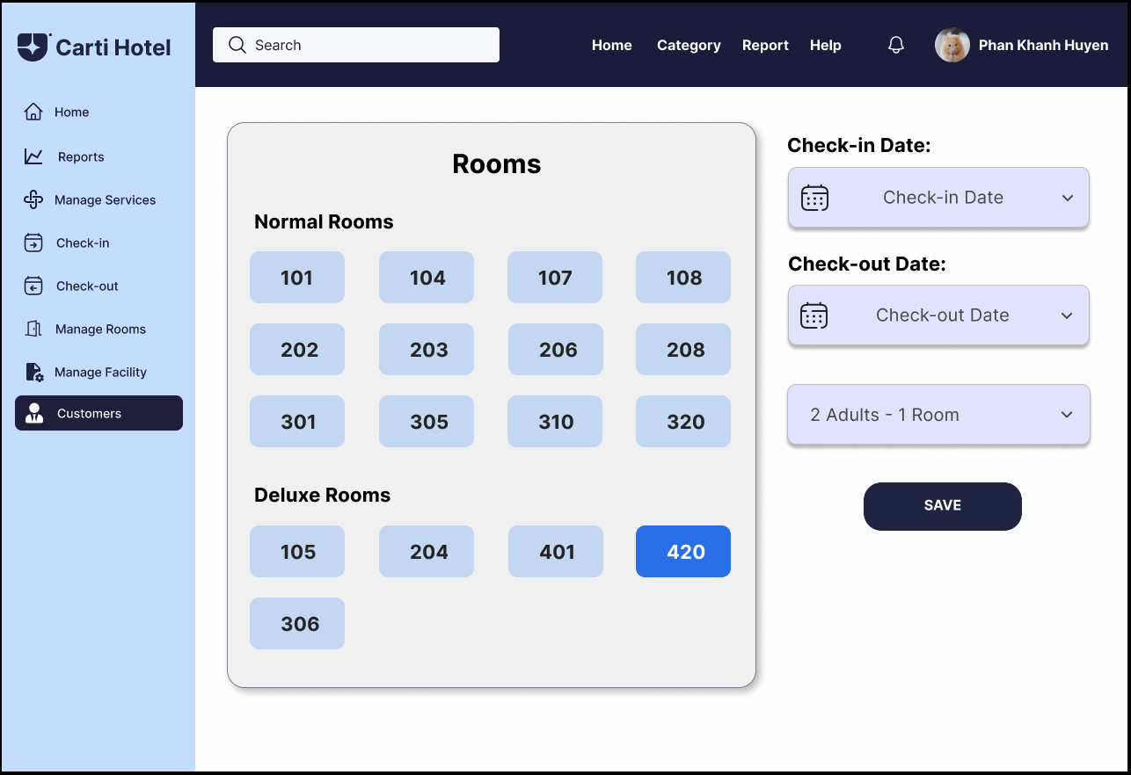

After choosing all the information to check-in for the customer, click the Save Button. A success message will show up if the rooms chosen are available:

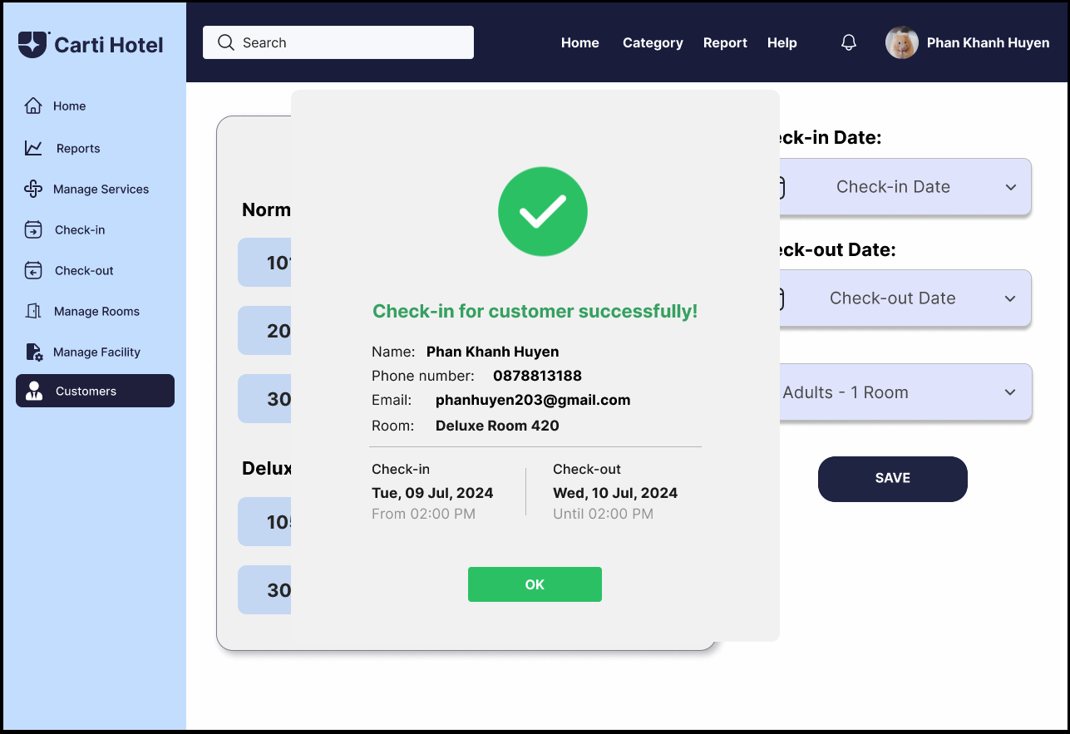

**MAKE PAYMENT**

On the Confirm Booking Page, the customer clicks on the green **Make Payment Now** button to process the payment

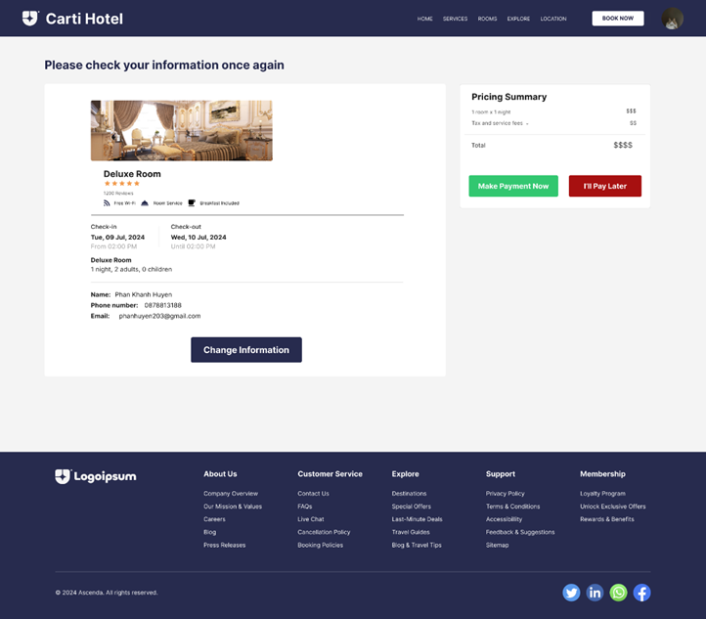

After clicking **Make Payment Now** a modal is displayed with available payment methods. The customer selects a method and click **Continue**

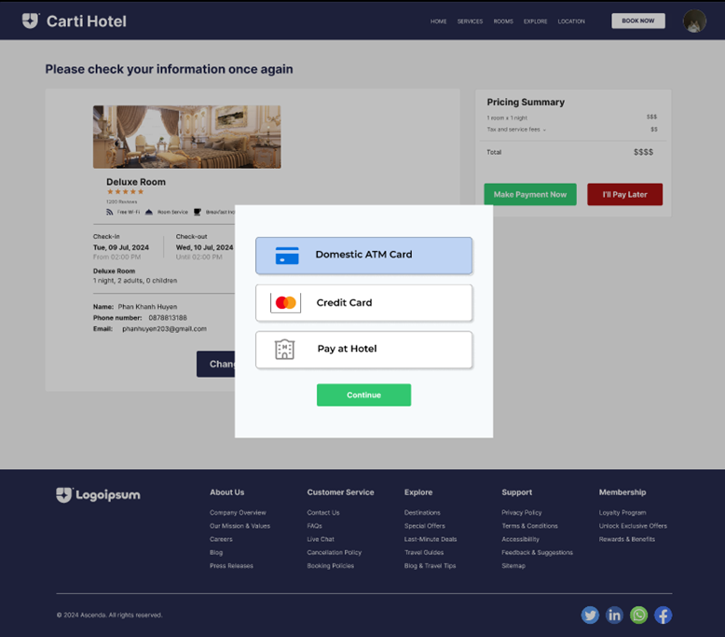

After selecting a payment method, the customer is required to enter information based on which method they selected. After filling all the required fields, the customer clicks **Make Payment**

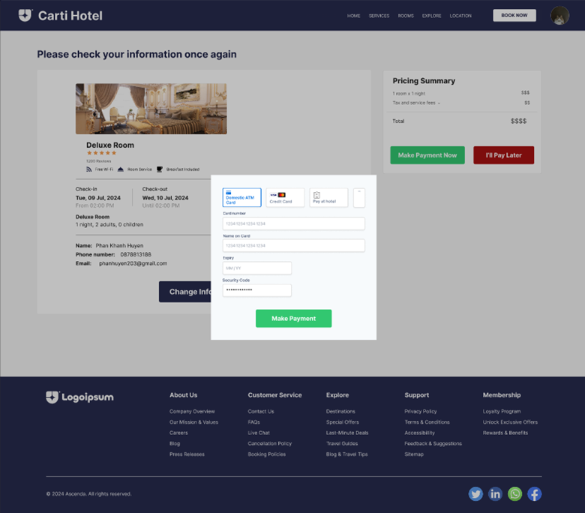

The customer confirms the payment. For example, providing PIN for Domestic ATM Card payment method.

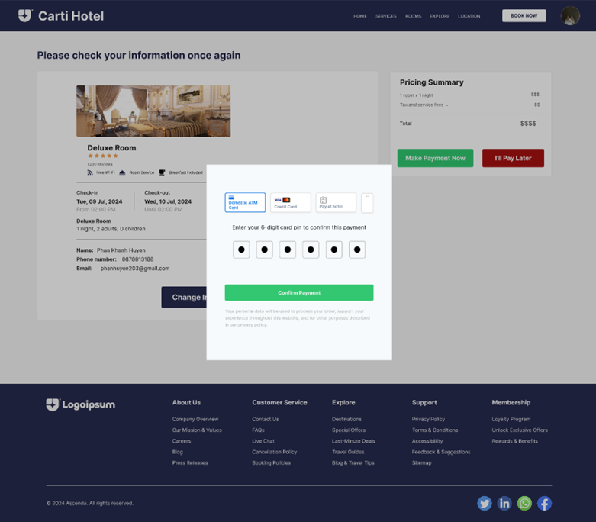

The system displays a message to notify whether the payment is successful or not.

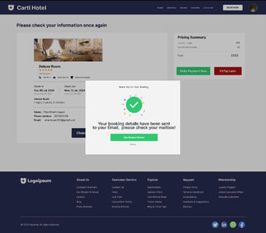 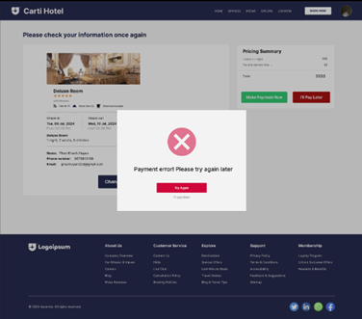

**MANAGE ROOMS**

The admin clicks on the **Manage Rooms** button to see the room list, clicking on **Add Room** button to add a new room

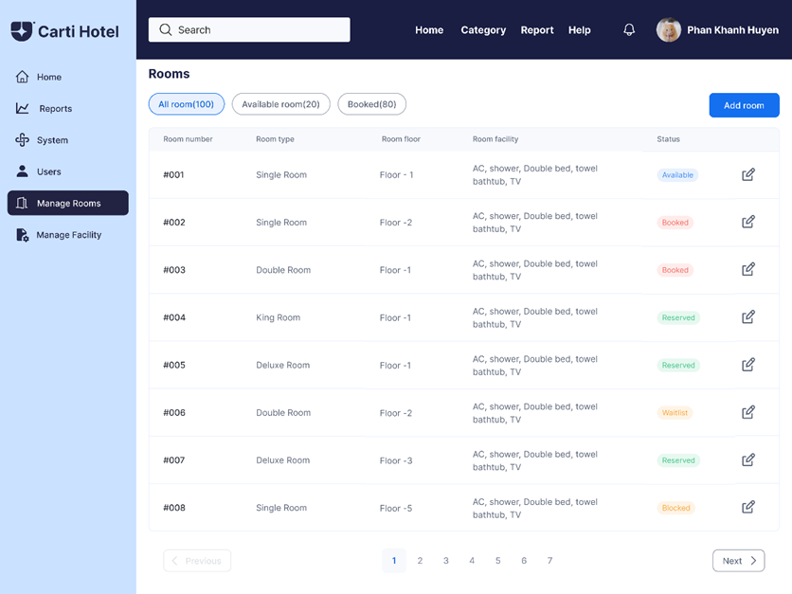

After the admin clicks the **Add Room** button, an Add Room Modal is displayed.

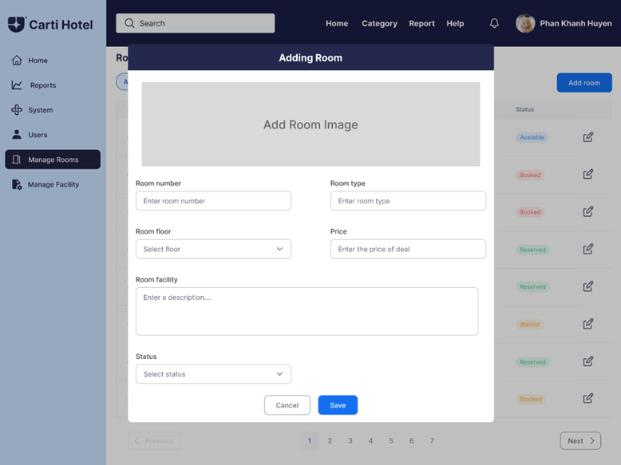

After filling the information and clicking **Save** button, a message is shown to notify the admin of the adding success or failure

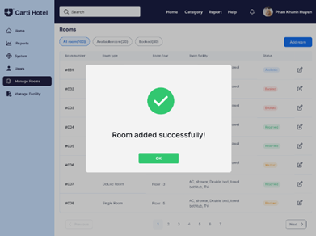 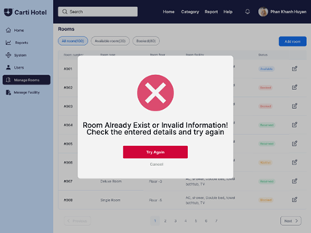

On the room list, clicking on edit icon to see **Update Room** and **Delete Room** options, then clicking on **Update Room** button to see Update Room Modal

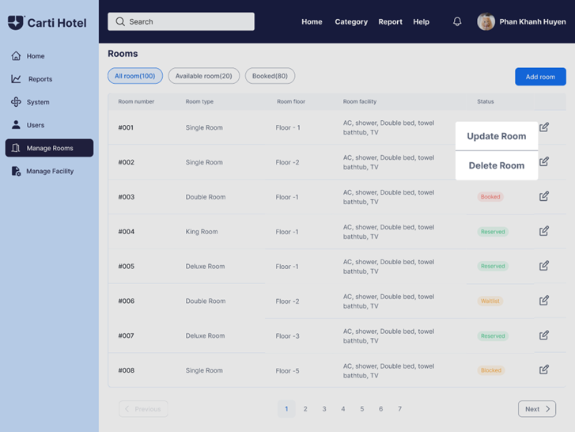

On the Update Room Modal, the room information is displayed, the admin change the existing information and click on **Save**

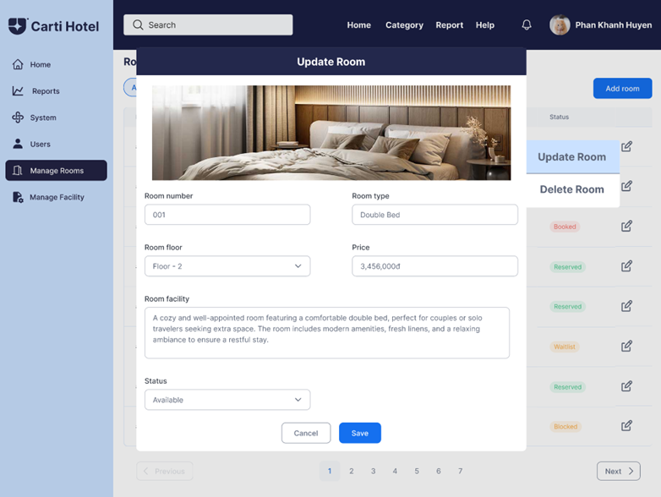

After clicking on **Save**, the admin is notified about the success/failure with a message

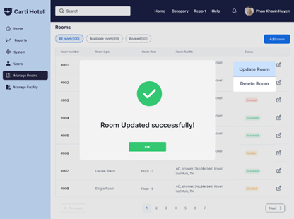 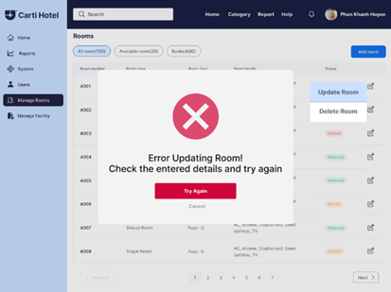

On the room list, clicking on edit icon to see **Update Room** and **Delete Room** options, then clicking on **Delete Room** to delete the room

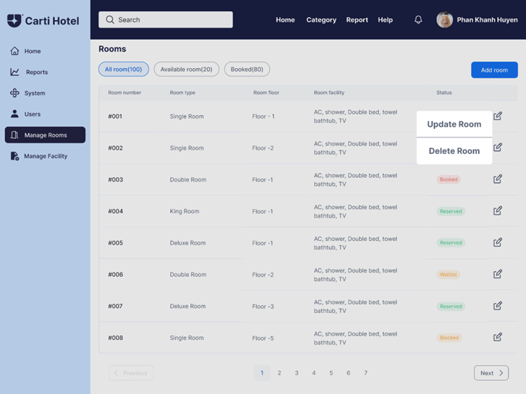

A Delete Prompt is shown to confirm the deletion

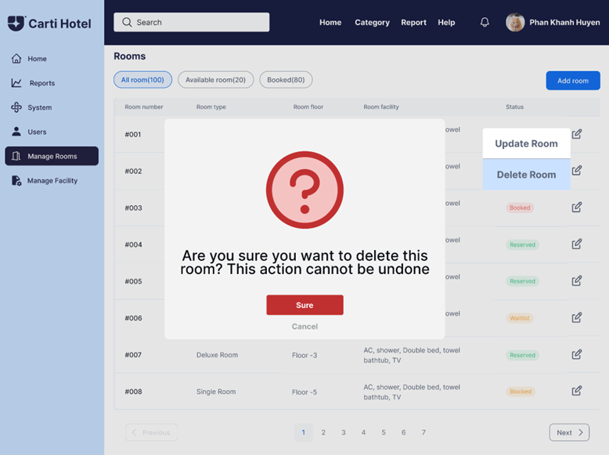

The admin clicks **Sure** to confirm the deletion, then a message is shown to notify the successful deletion

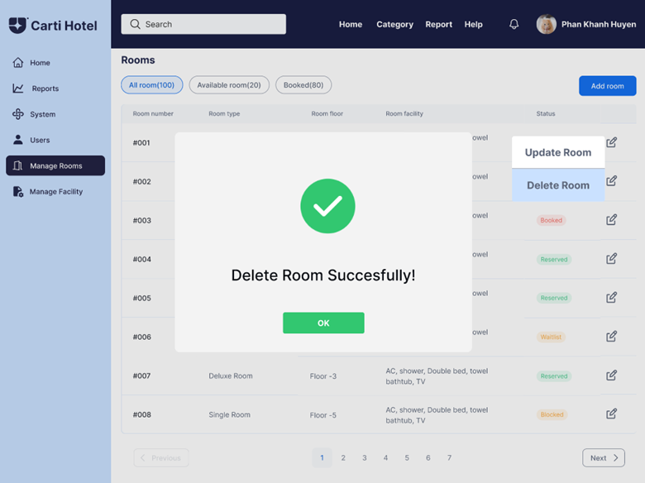

**MANAGE USERS**

In the Admin Page, there are some functional buttons on the navigation bar such as Home Page, Category, System, Report, Users, Facility, and Rooms. The remaining part displays the status of rooms in the hotel.

The darkest blue color with the status “Vacant Ready” means this room is willing to welcome customers. The grey color means this room is being cleaned. The lightest blue color means this room is busy. Admin hovers on the Report button and then clicks on the Revenue Report. To manage users, the admin hovers on the Users Button, after which 3 options will show up: Add User, Delete User, Update User.

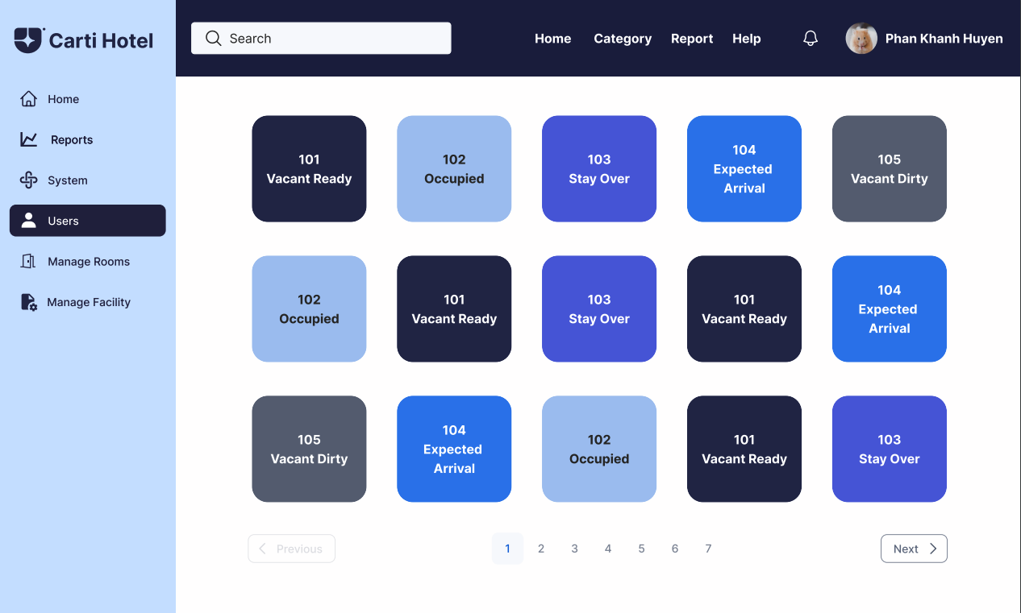

The admin is required to click on the Users button on the left side, and after that click on the Add User button.

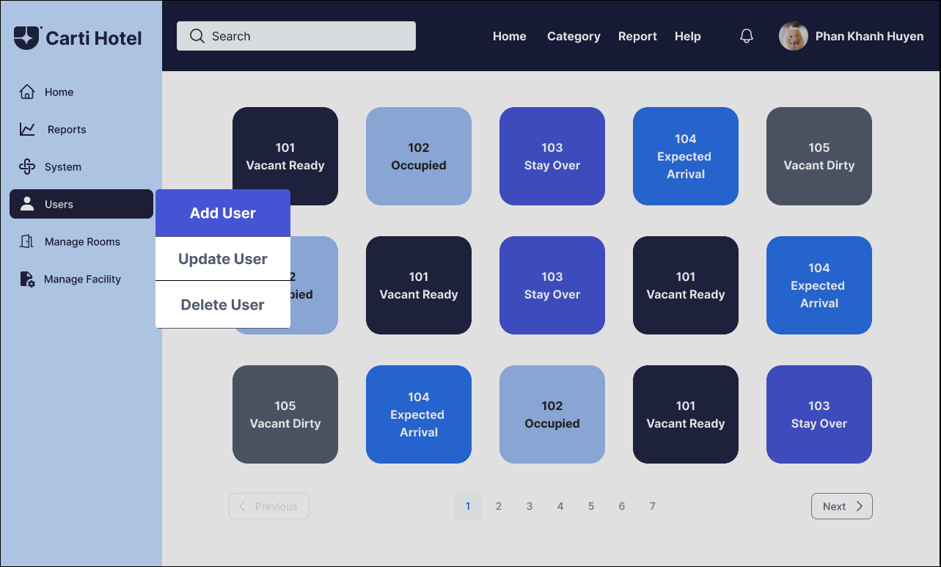

The admin will be navigated to the Add User page. Then, the admin is required to input information into a form to add a new customer. If the input data is valid, at the end of each block will appear a green tick, otherwise, a red cross will appear. Below on the right-hand side of the form is the Save button with the same color as the main dark blue color of the website.

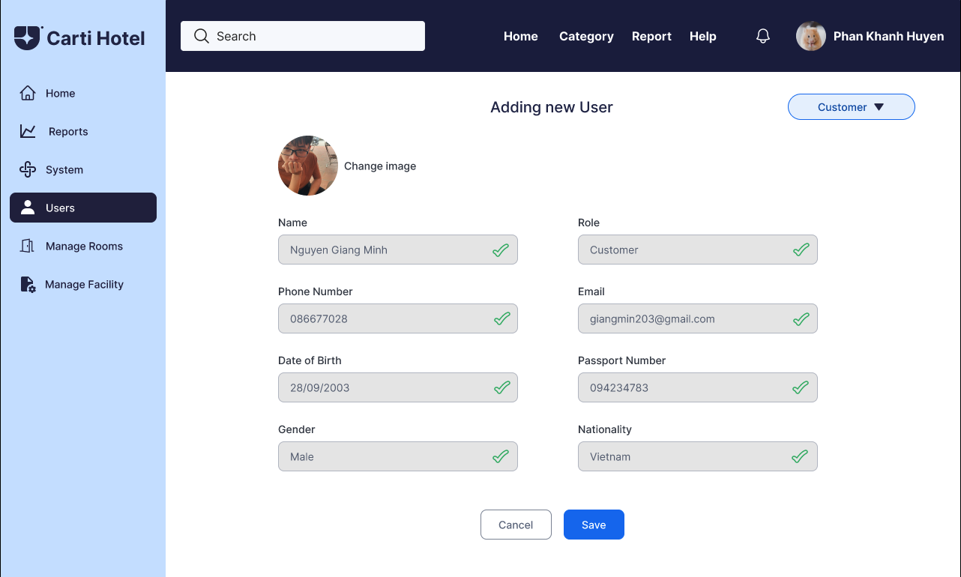

If the admin wants to add a new receptionist, he/she chooses the option Add Receptionist in a drop down menu above the form, and then all the user’s required information will be switched to receptionist information.

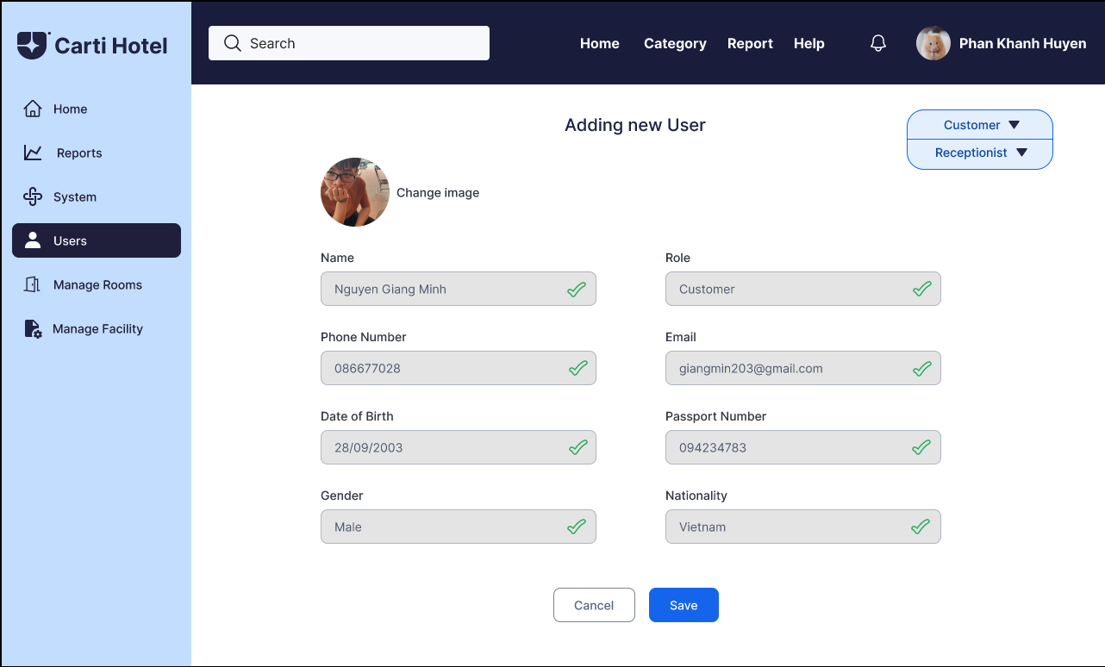

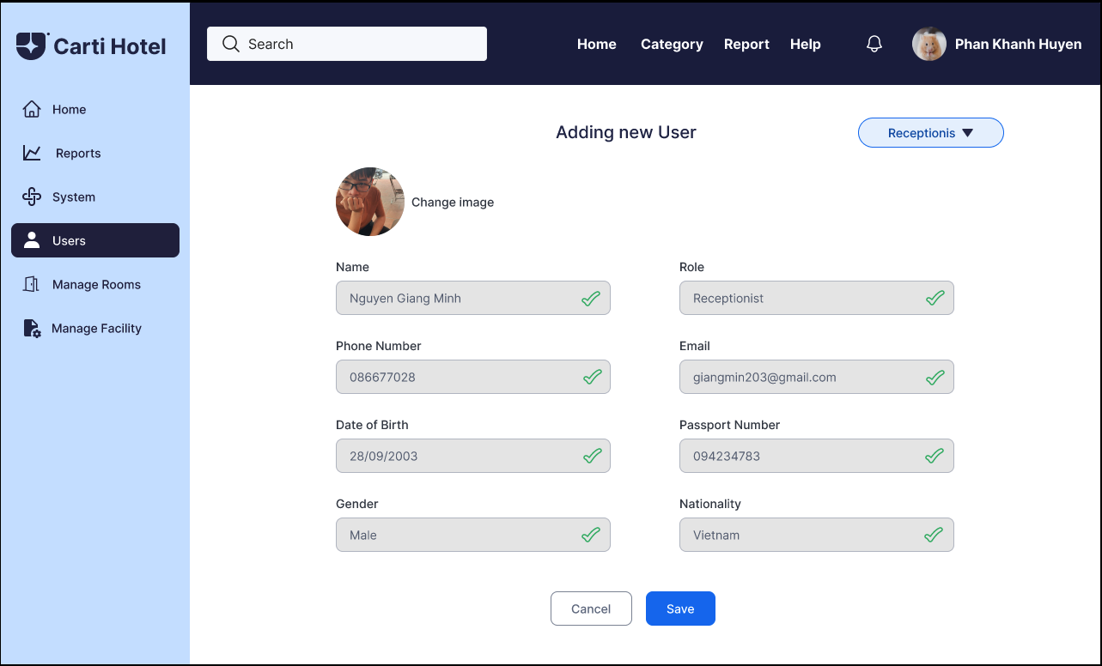

After inputting all the required information, the admin clicks the Save Button. A square success message box will be shown if nothing goes wrong.

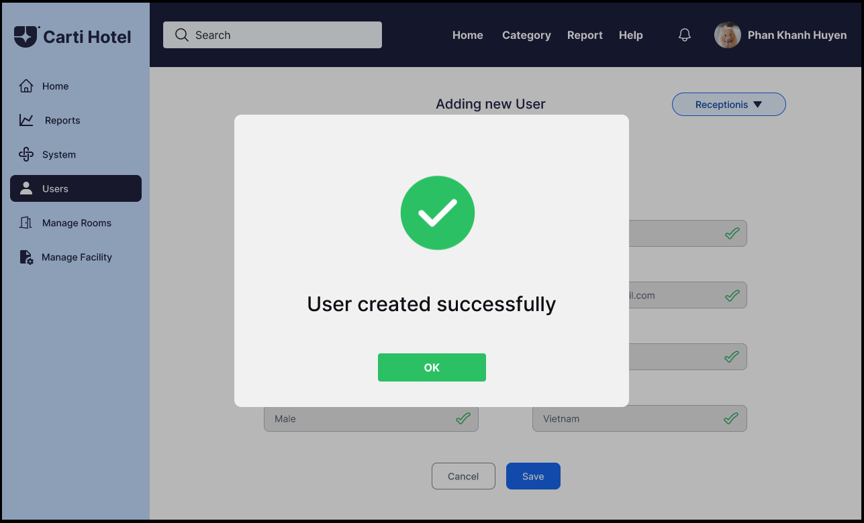

To update or delete an existing user, on the homepage, after clicking the Users Button.



Three options to manage users will appear and the admin must click the delete user button.

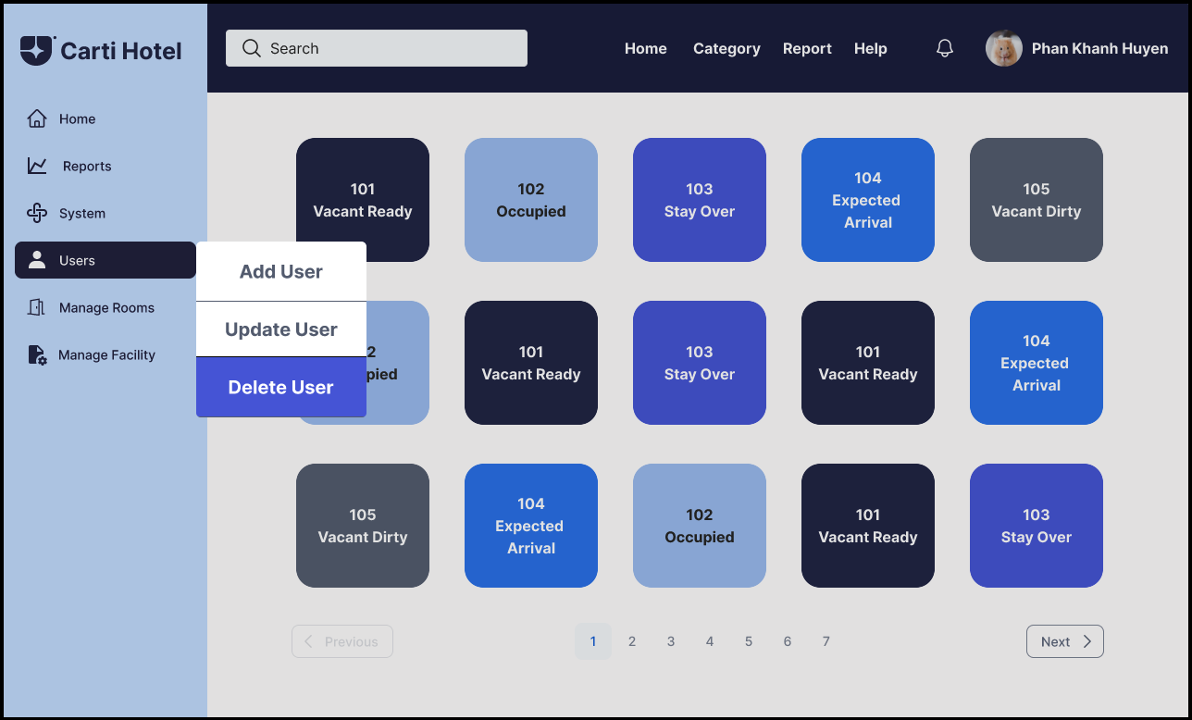

The list of users will appear and the admin will have to click on of the user row to delete that user.

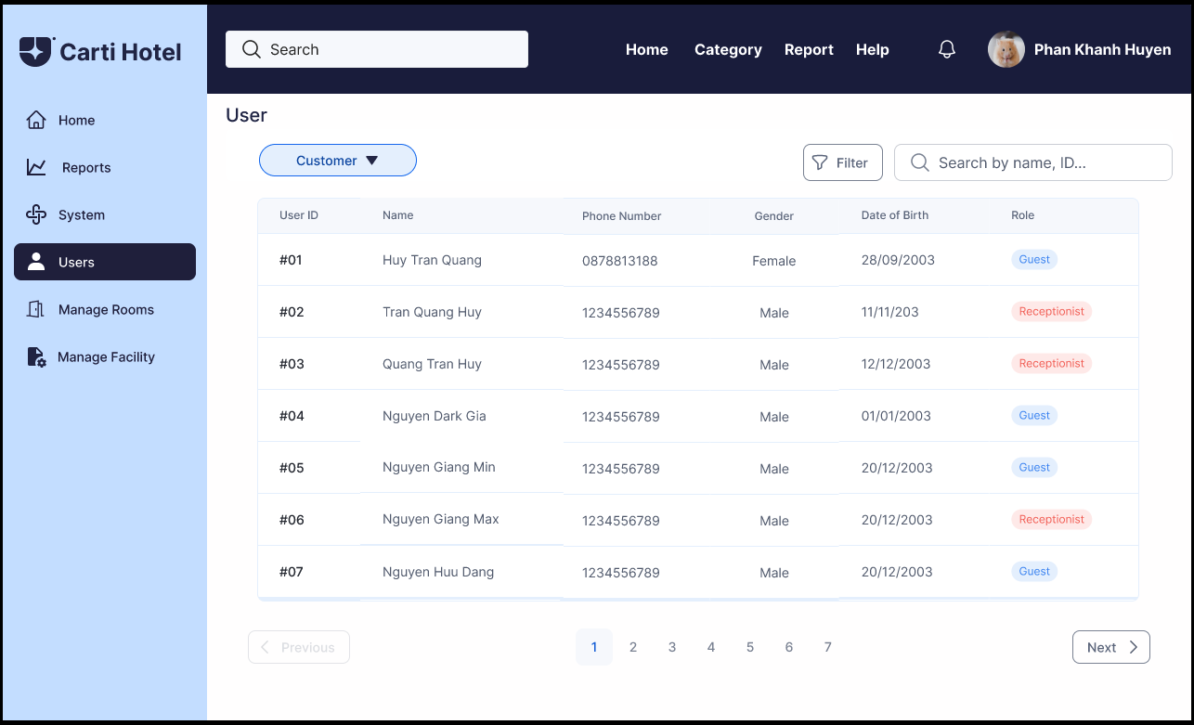

After clicking on one of the users which he or she wants to delete, the message box will appear and click “Yes” to confirm deleting a user from the list or click “Cancel”.

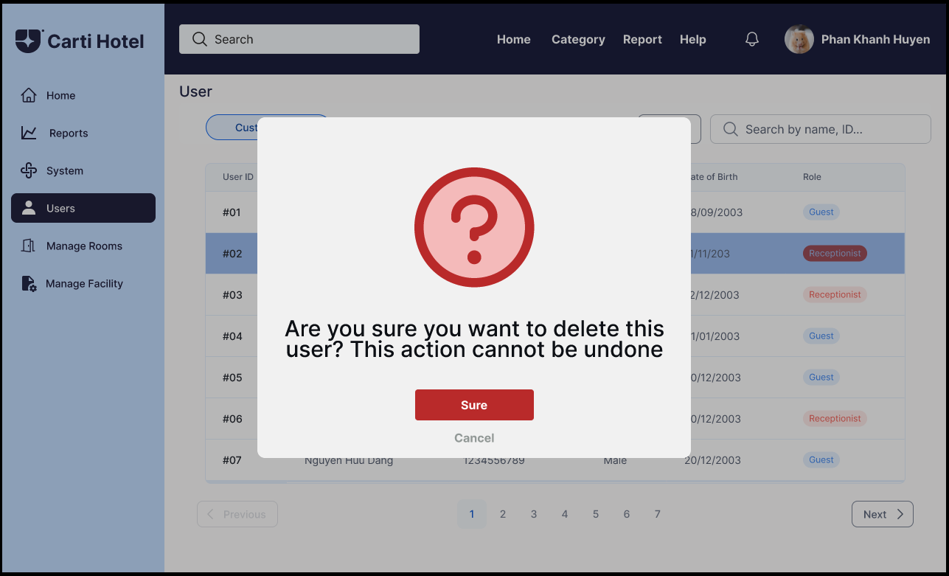

A message box notifying successful deletion will then appear:

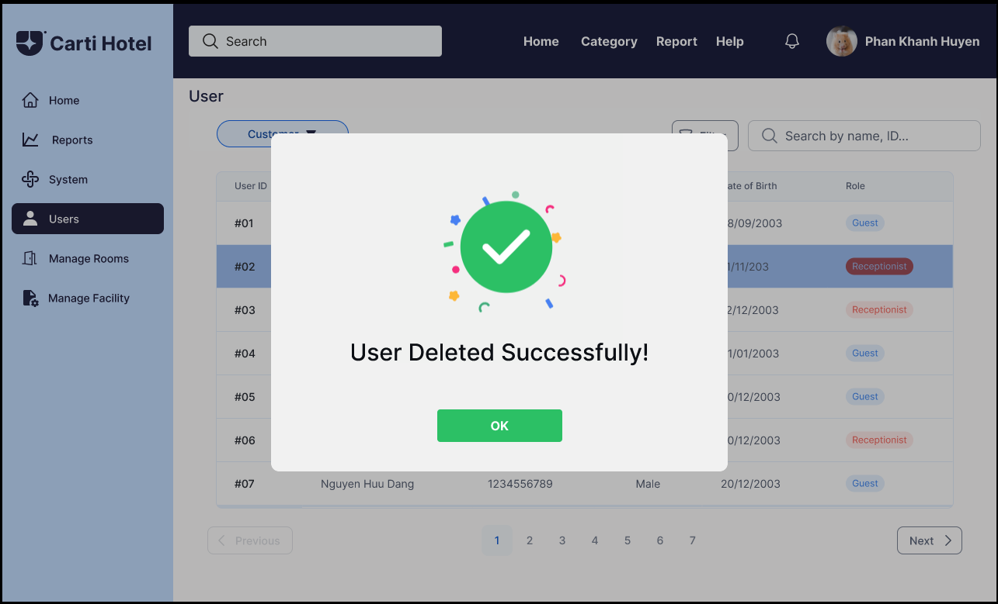

To update the user, the admin clicks on the Users Button.



Then the admin will need to choose the Update User button and is directed to the user listing page.

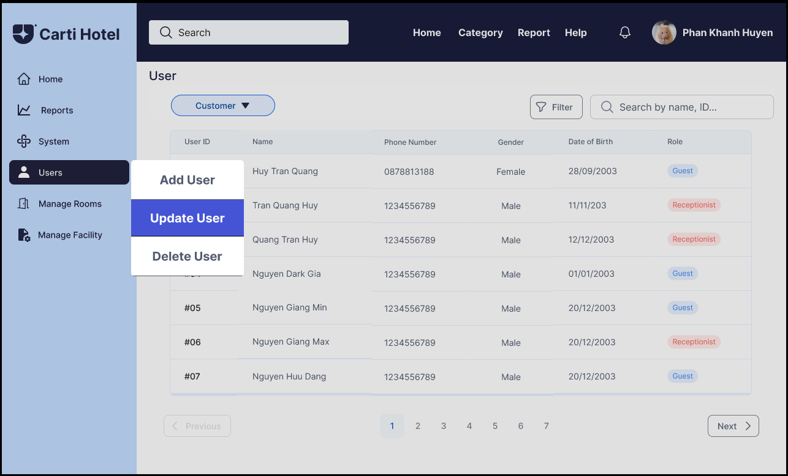

The list of users will appear on the screen of the admin page.

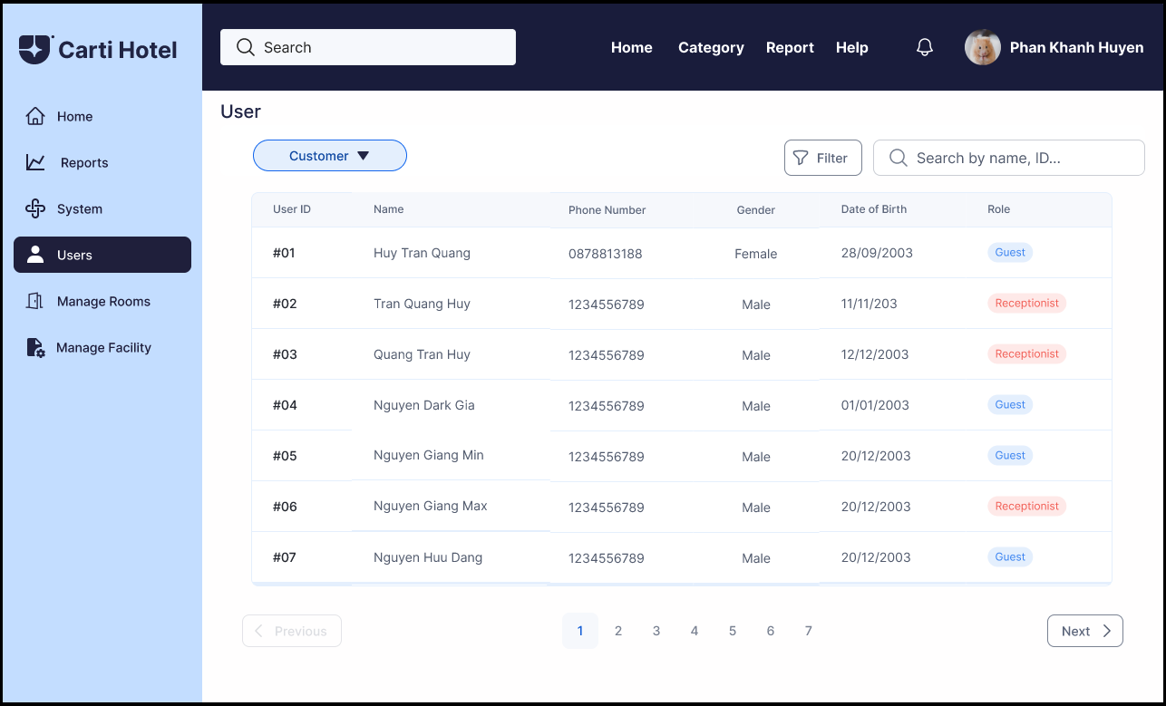

Clicking on one of the user rows will direct the admin to the update user page.

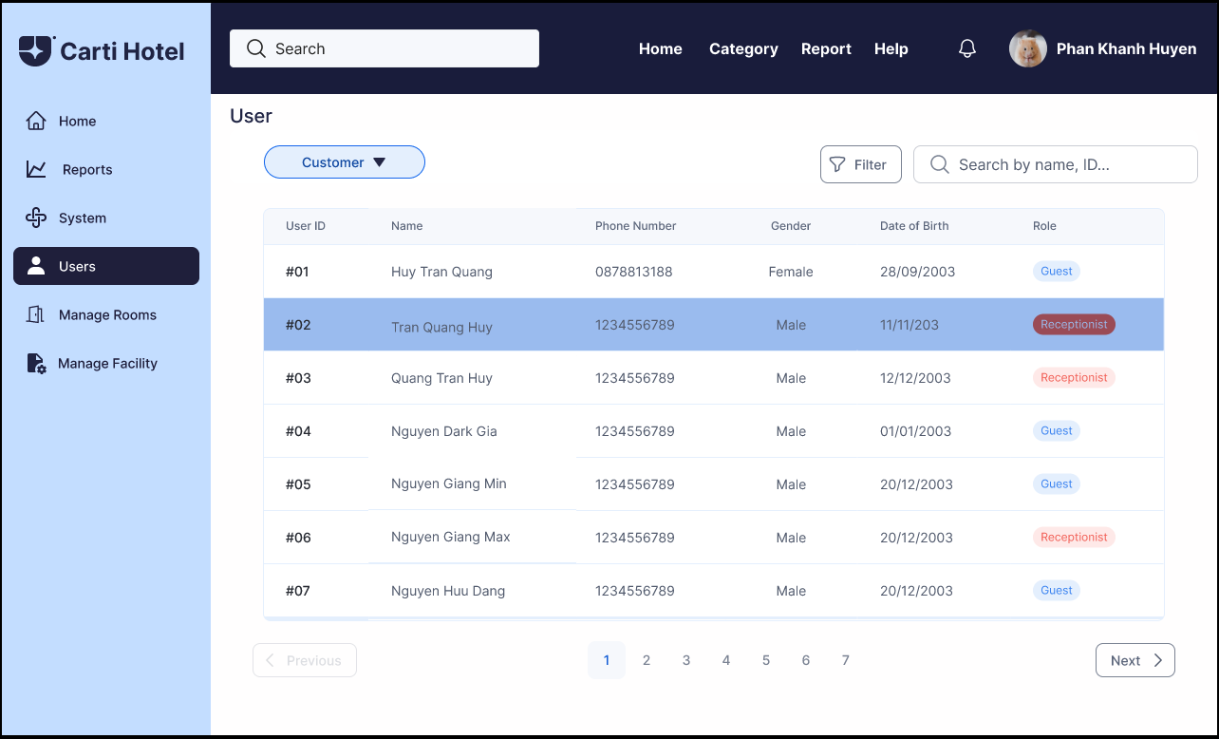

In this step, the admin can change the information of the user in each field.

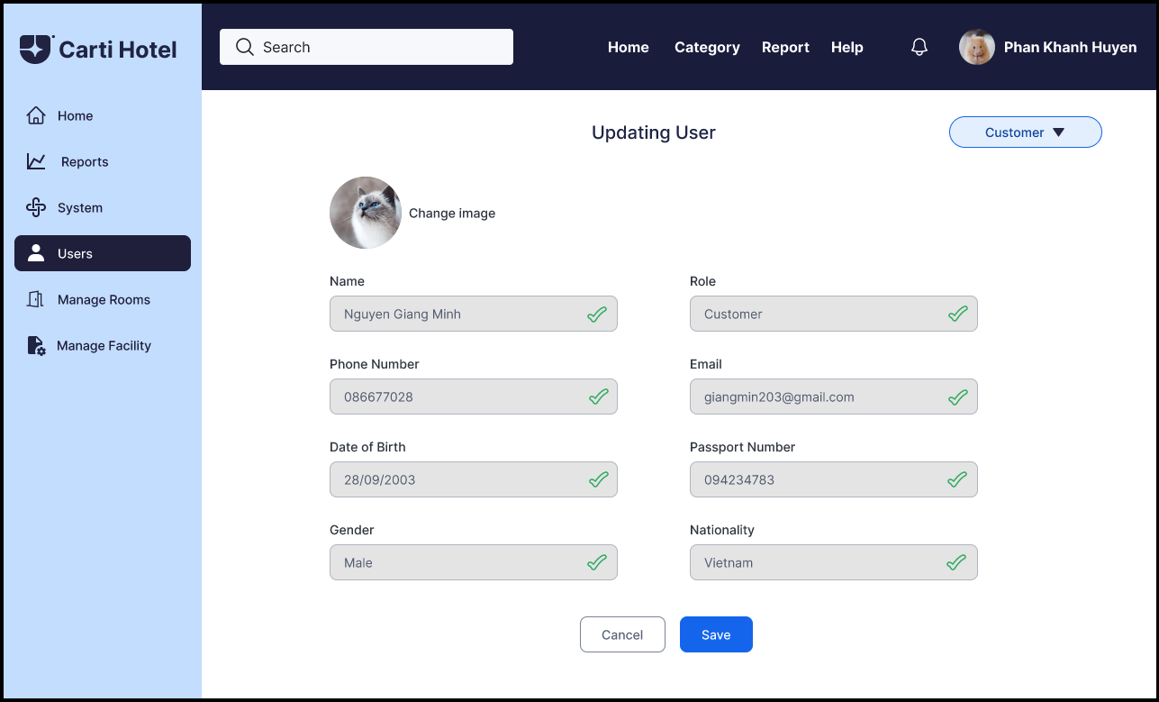

To finish updating the user’s information, click the Save Button, and a success message will be shown if nothing goes wrong.

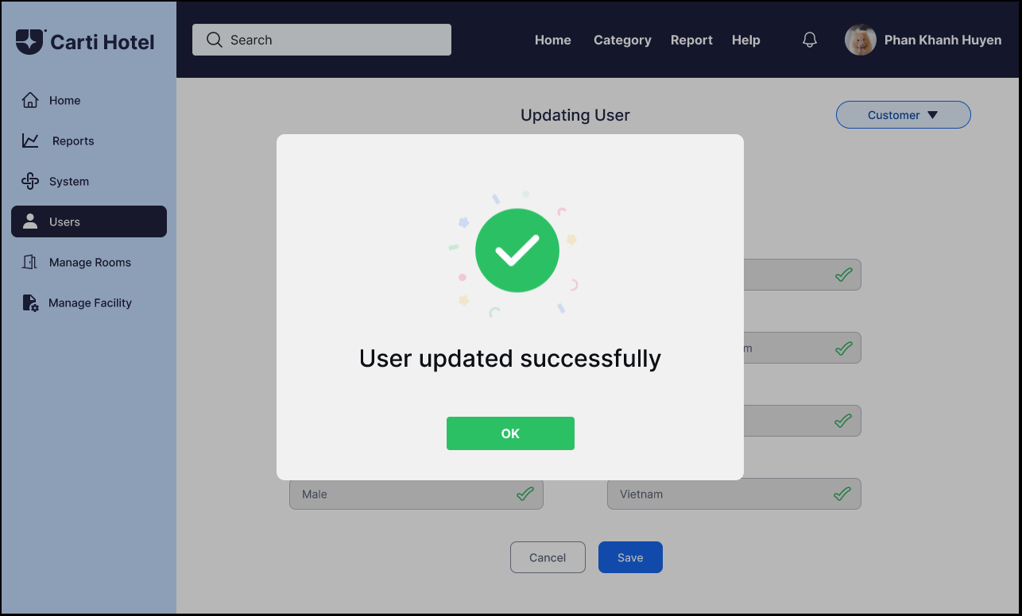

Otherwise, an error message will be shown, and notifying the admin which input was invalid.

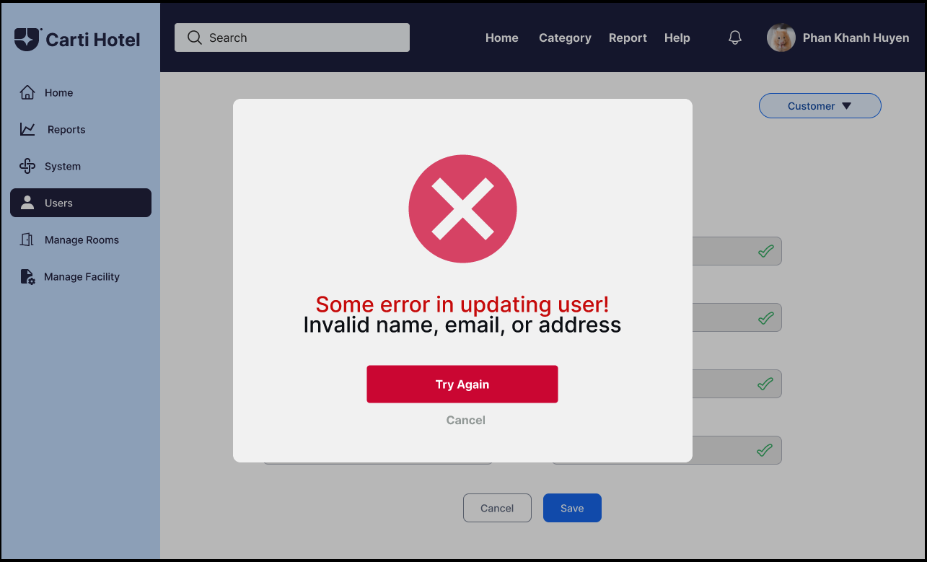

**MANAGE SERVICES**

On the Receptionist Page, functional buttons like Home Page, Manage Services, Report, Manage Rooms, and Manage Facility are situated on the left side. The remaining section provides an overview of the hotel's room status. Rooms marked with the darkest blue color and labeled "Vacant Ready" indicate their availability for customers. Grey-colored rooms are currently undergoing cleaning, while the lightest blue color signifies occupied rooms. The other two types of blue color either means the room already expecting customers or it’s being stayed over.

To initiate a search for a customer, the receptionist begins by entering the customer's name in the search bar and subsequently clicking the Search Button. This action prompts the display of a list containing customers whose names match the entered criteria:

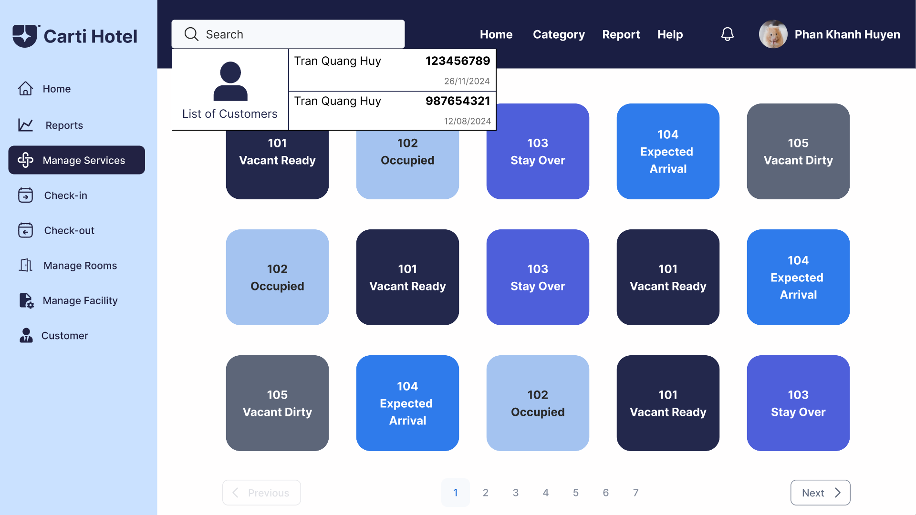

The receptionist clicks on a customer, then the reservation details of that customer will be shown. The details include check-in, check-out date, total length of stay, room type, total price as well as the customer’s name, phone number, and email. Below on the bottom left corner of the screen is the Service Listing button.

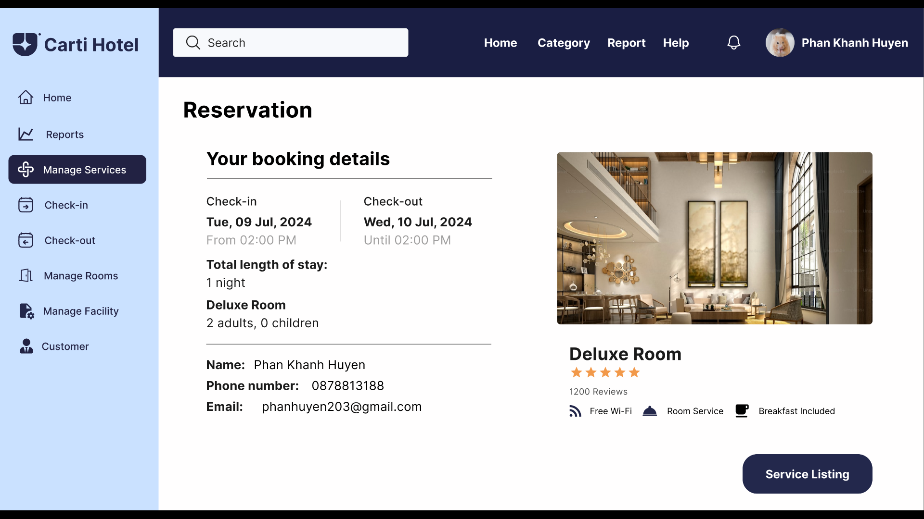

By selecting the Service Listing Button, the receptionist gains access to a table displaying the services that the customer has ordered for the reservation. This table includes three columns: service name, quantity, and price. Adjacent to this table, there is a Services block containing a comprehensive list of all services provided by the hotel. At the bottom right of the page, the Add Service button is prominently featured.

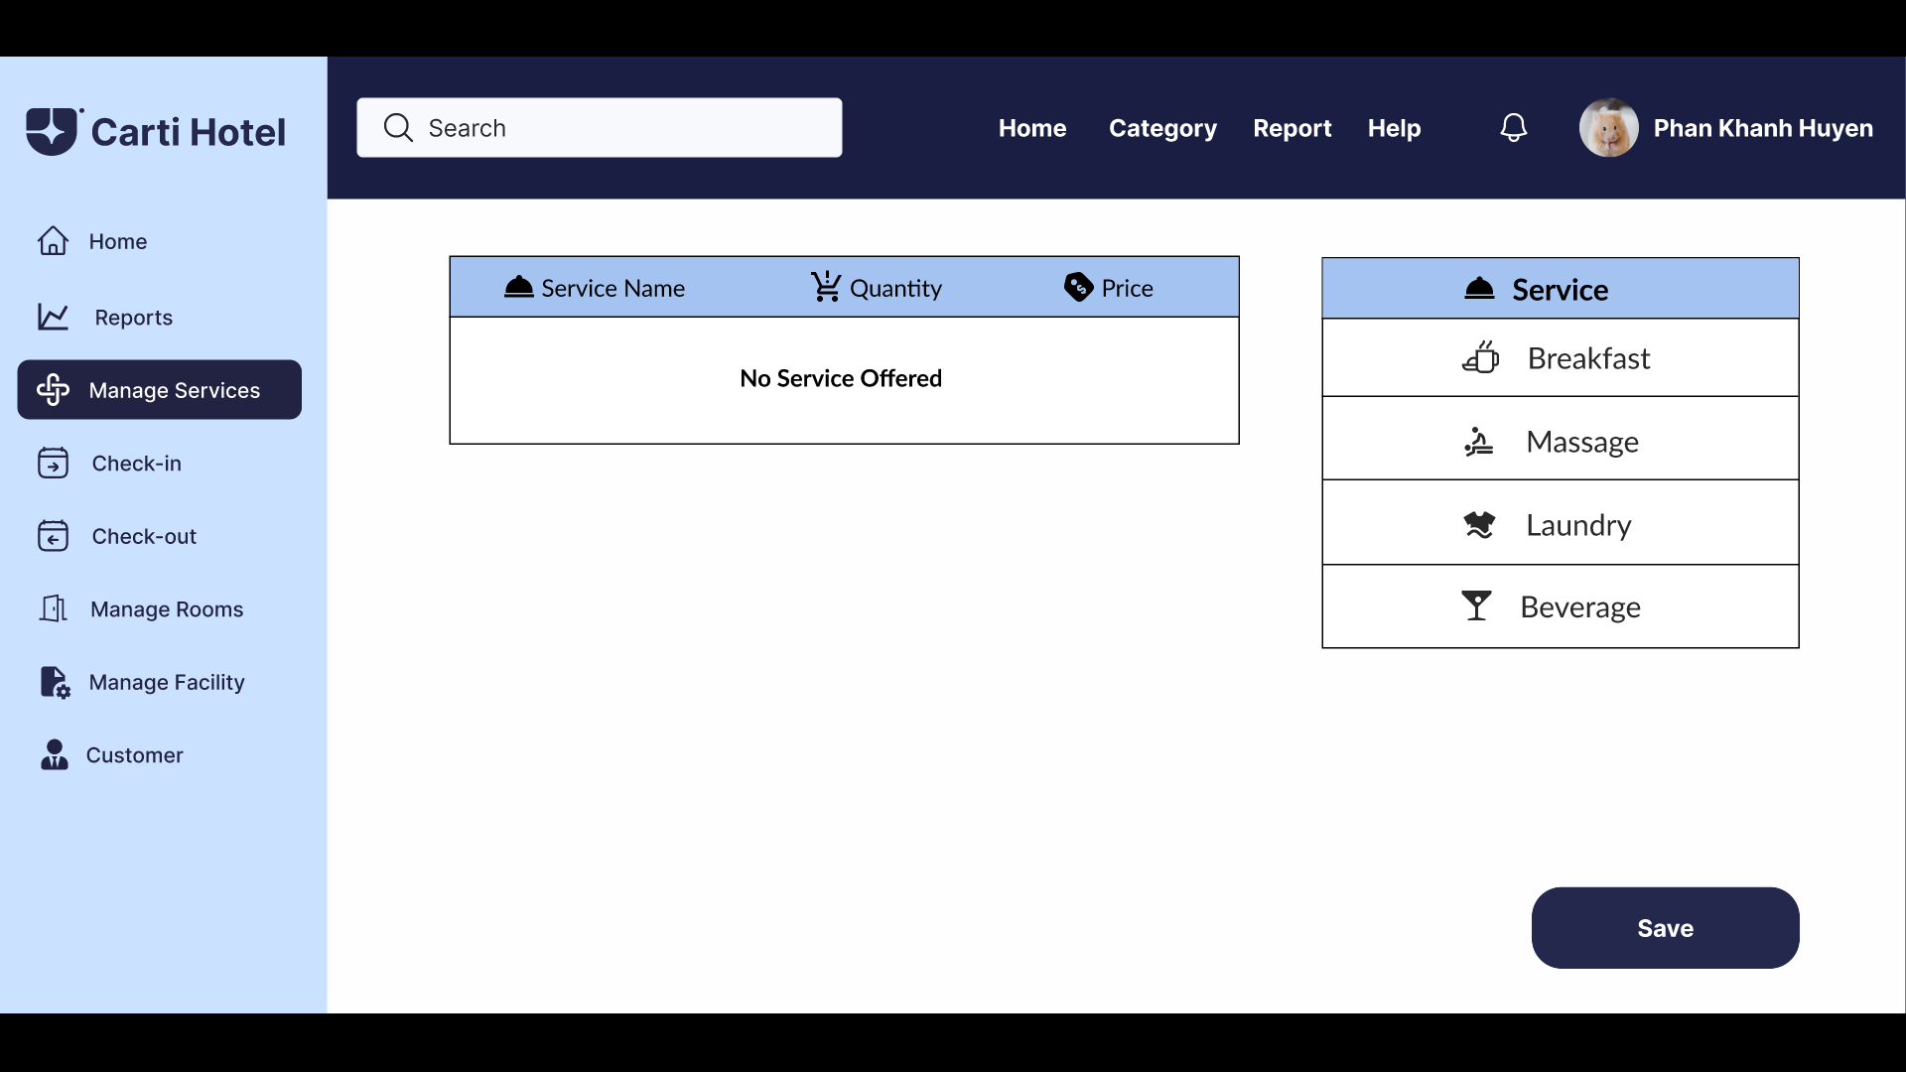

The receptionist has the option to select the type and quantity of services that the customer has ordered. The cumulative price of all selected services is displayed in the Total block, situated just below the Add Service table.

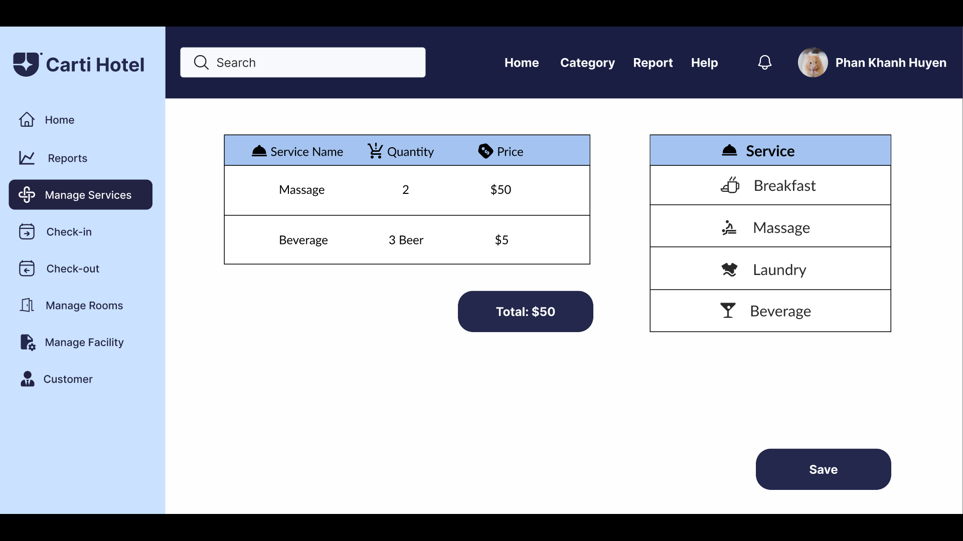

After the receptionist has finished choosing services, click on the Save Button, and a success message will be shown if nothing goes wrong:

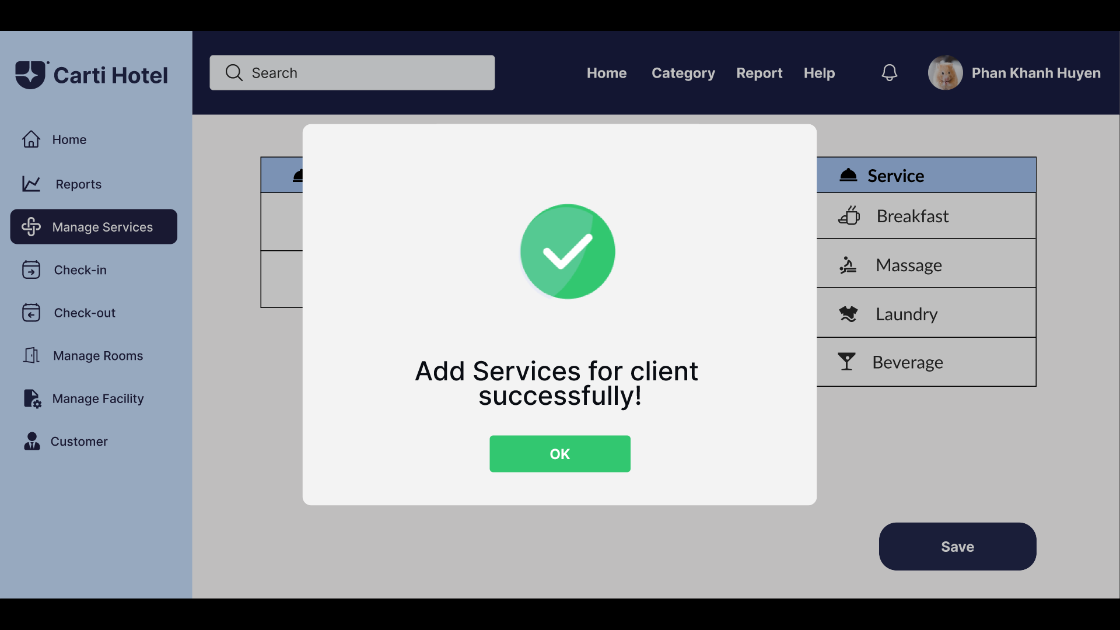

Otherwise, an error message will be shown:

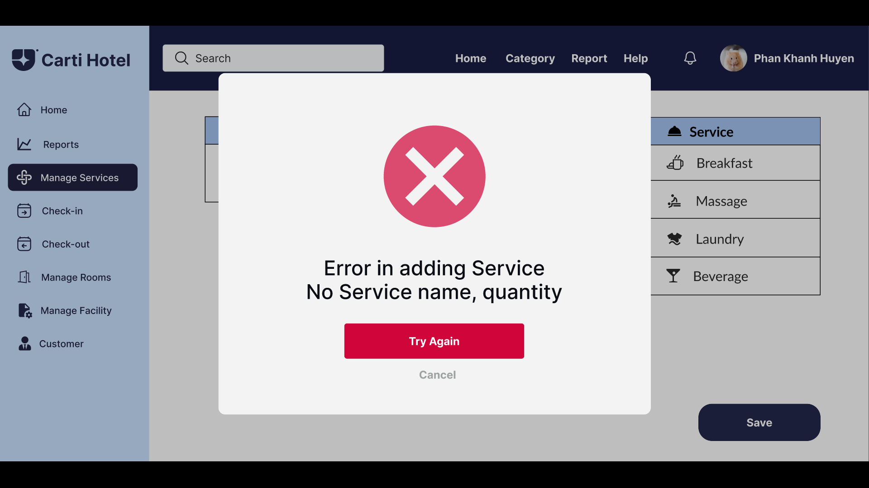

To remove a service from the customer's bill, the receptionist double-clicks on a service that the customer has ordered, causing that row to appear in front and a Delete Service Button to appear.

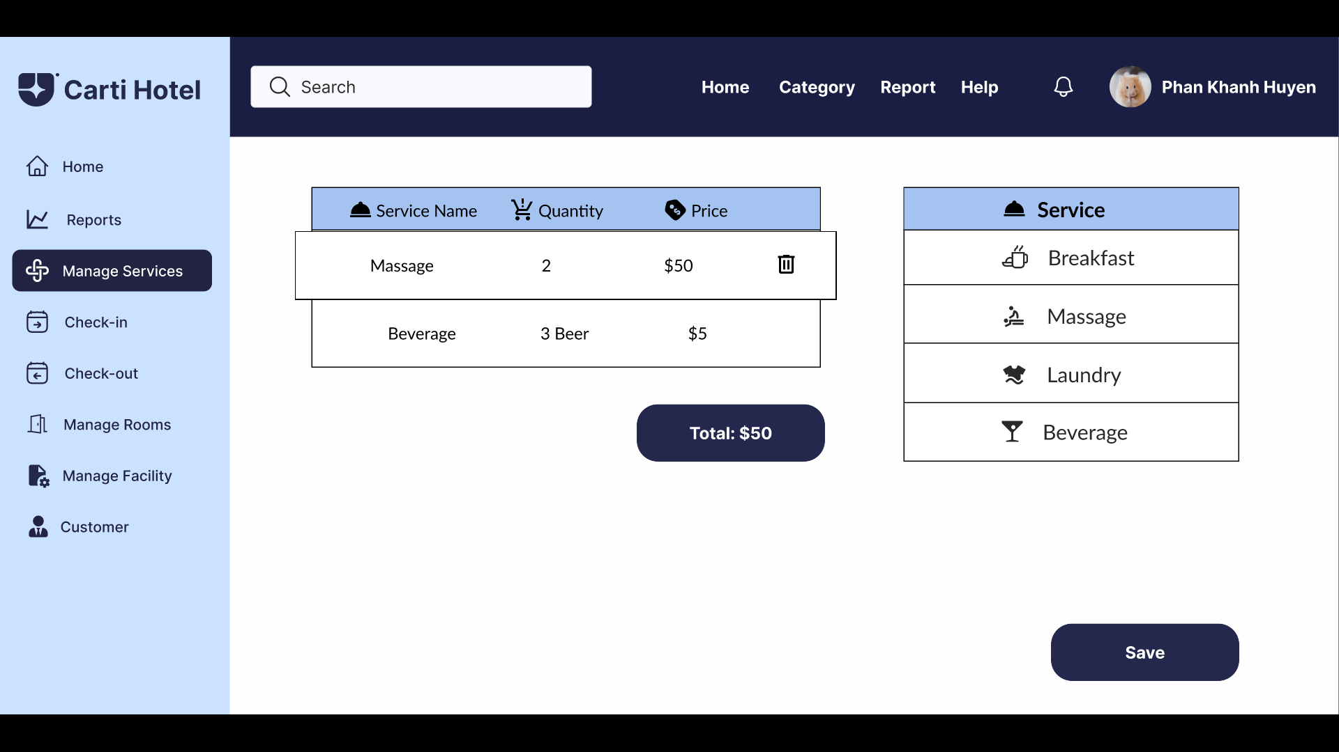

The receptionist clicks on the Delete Service Button. A confirmation box will show up:

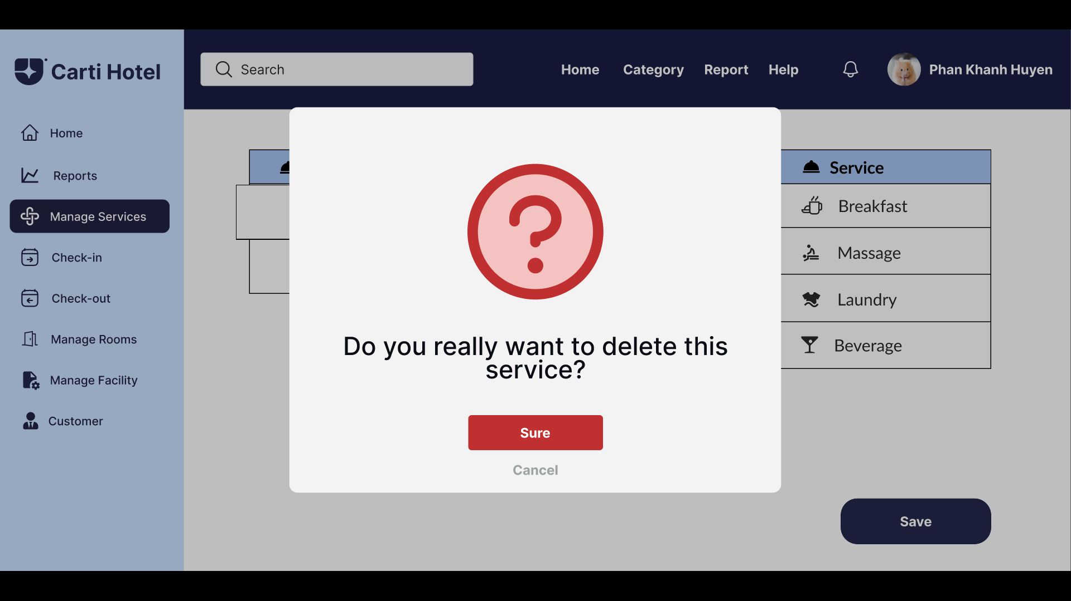

If the receptionist accepts to delete the service, click the “Yes” button. A message box will appear notifying successful deletion:

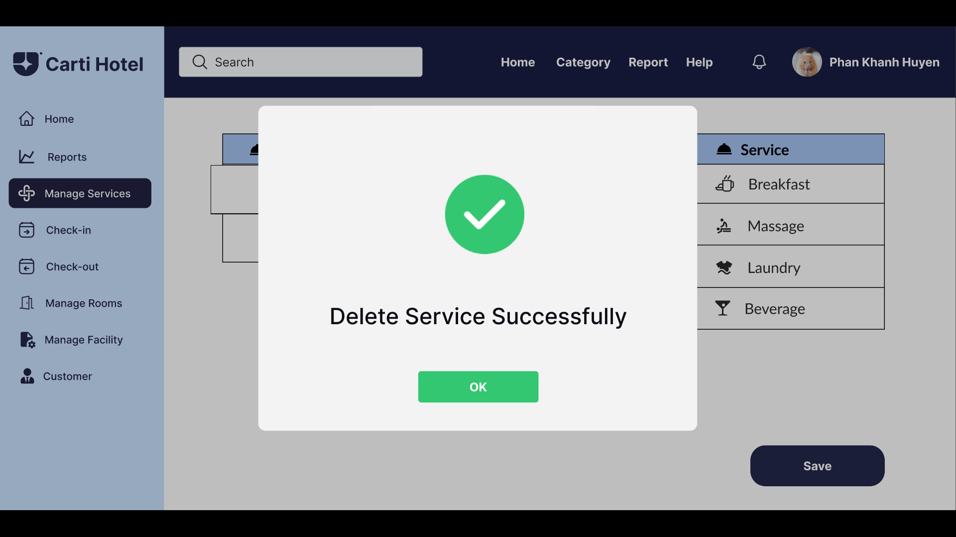

**VIEW REVENUE**

On the Admin Page, a sidebar on the left provides functional buttons such as Home, Category, System, Report, Users, Facility, and Manage Rooms. These buttons allow the admin to navigate through various management functionalities of the hotel.

The main section displays the current status of hotel rooms in a grid format. The room statuses are represented by different colored boxes: blue indicates "Vacant Ready" for rooms available for new guests, light purple shows "Expected Arrival" for rooms reserved for incoming guests, dark blue represents "Stay Over" for rooms occupied by guests staying multiple nights, and grey highlights "Vacant Dirty" for rooms requiring cleaning.

When the admin hovers over the "Reports" button in the sidebar, a dropdown menu appears, listing options such as Revenue Report, Marketing Report, Facility Report, Staff Report, and Customer Report. Clicking on one of these options changes the background color of the selected button, indicating the report currently being accessed.

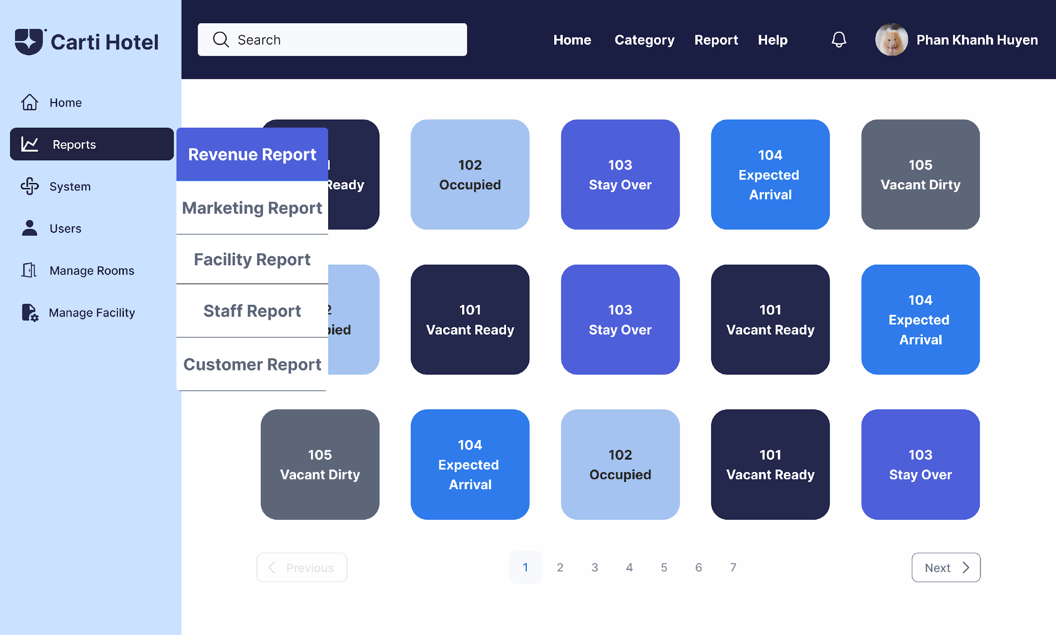

When the admin clicks on the Revenue Report button, the system redirects to the Revenue Report Page. At the top of this page, four options are displayed as buttons: Daily, Weekly, Monthly, and Yearly reports. These options allow the admin to select the desired type of revenue report. By default, the Monthly Revenue Report is displayed.

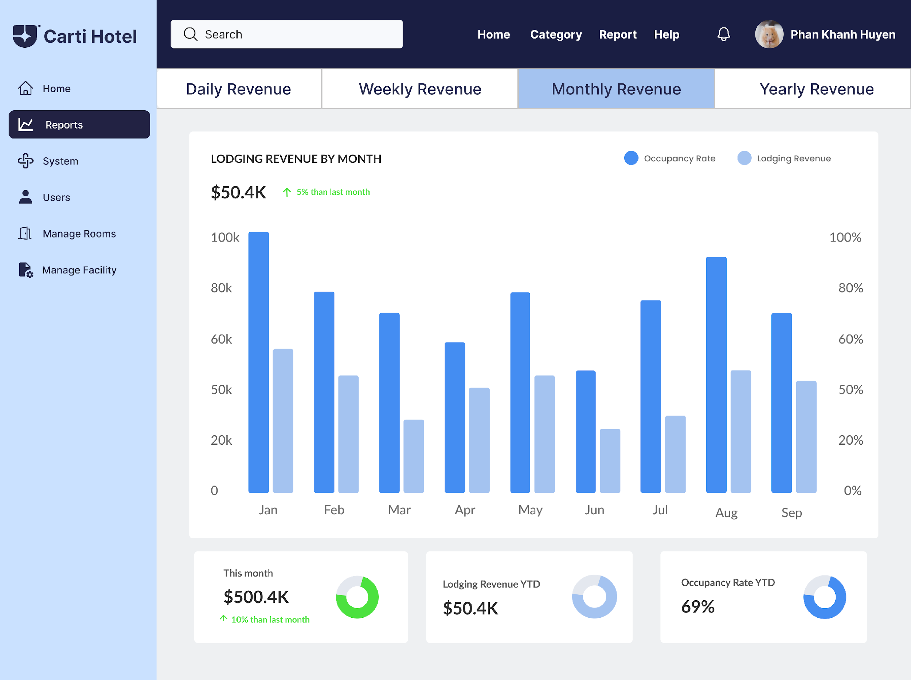

When the admin clicks on one of these buttons, its background color changes, visually indicating the selected option. Adjacent to this button is a calendar that enables the admin to select a specific time period for the report they wish to view.

After selecting a specific day, the admin is redirected to the Daily Revenue Report page.

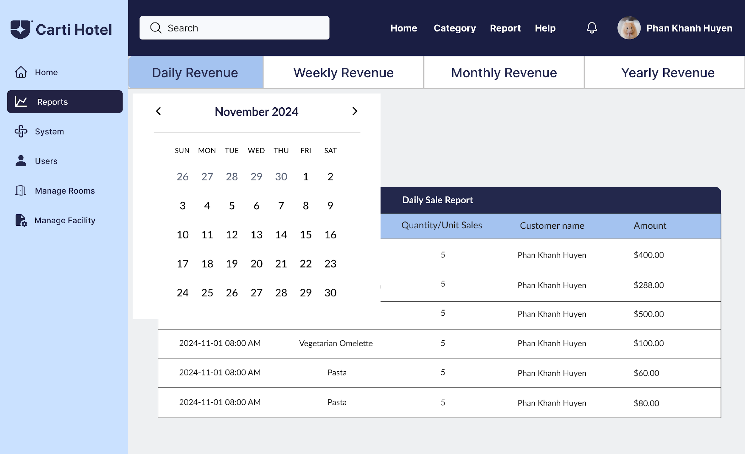

This page is displayed as a detailed table with columns such as Date/Time, Item/Dish, Quantity/Unit Sales, Customer Name, and Amount. Each row contains data on individual transactions, allowing the admin to easily review the daily revenue performance.

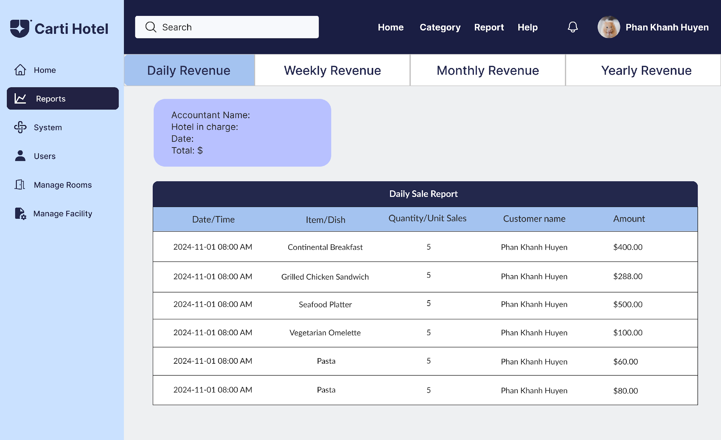

Selecting the Weekly Revenue Report button allows the admin to choose a specific week.

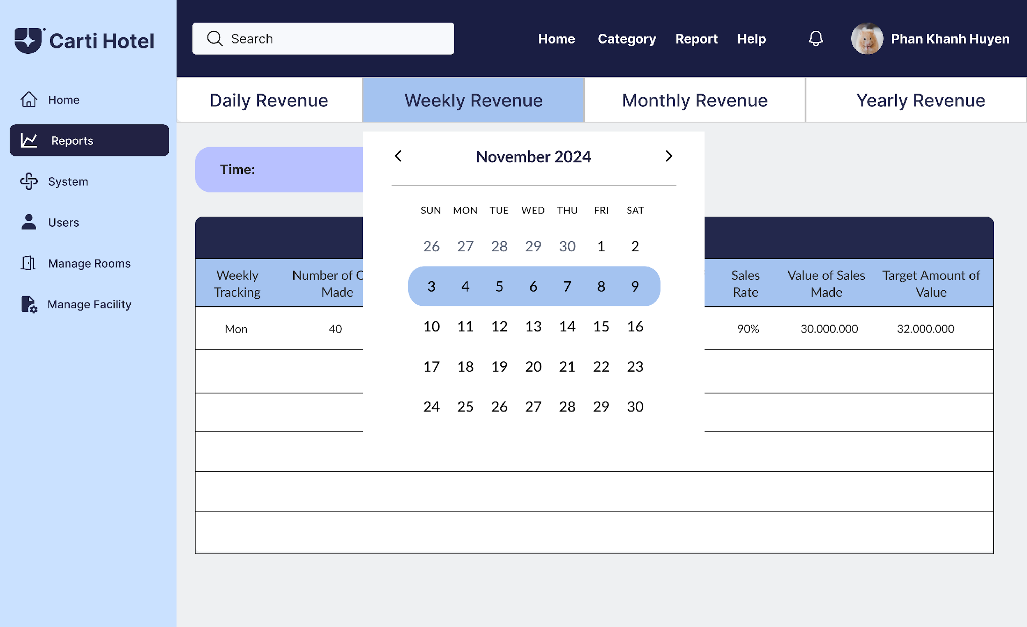

The system generates a weekly report displayed as a table, summarizing data for week from Monday to Sunday.

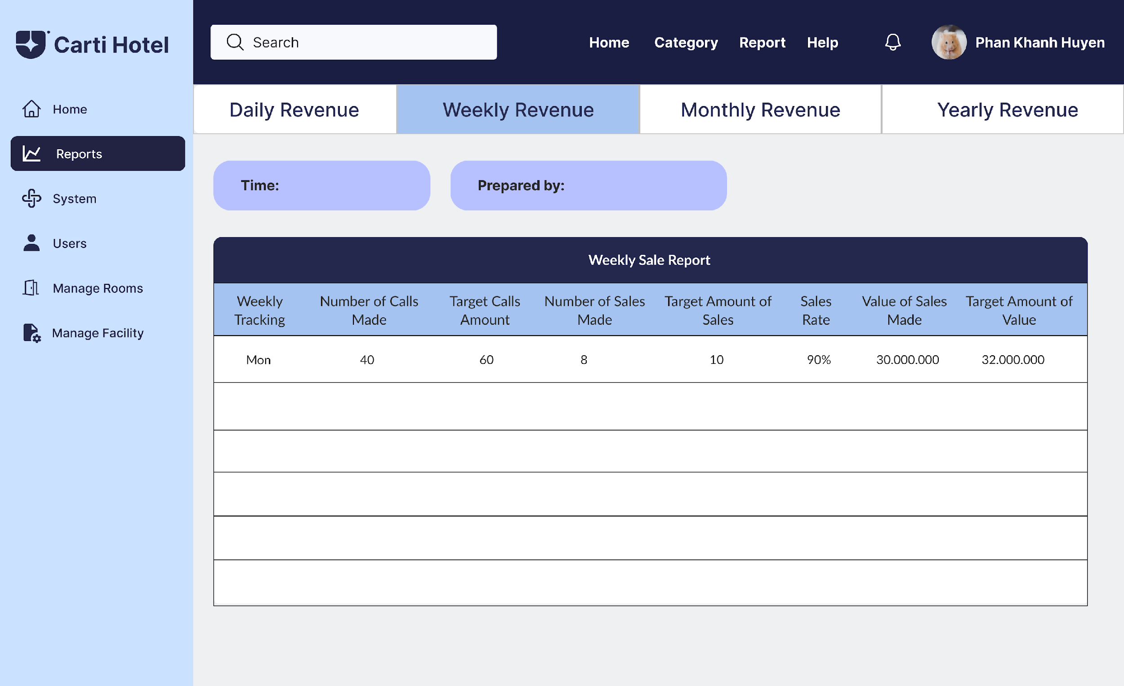

Choosing the Monthly Revenue Report button enables the admin to select a specific month.

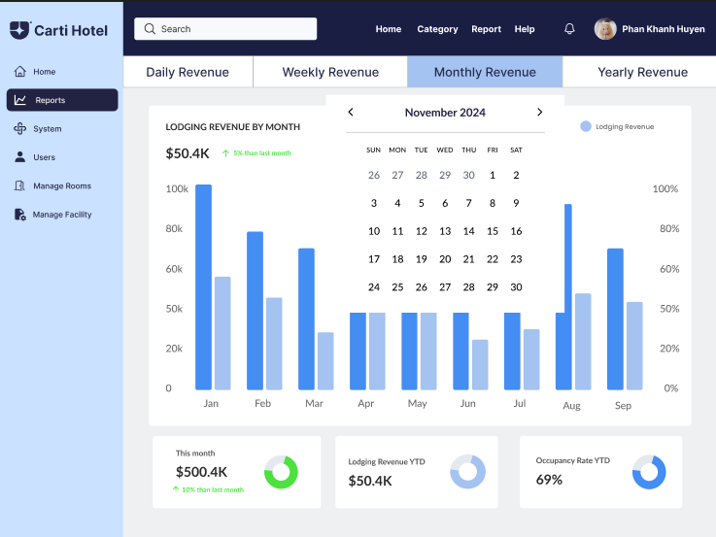

The Monthly Revenue Report page presents a detailed visual representation of lodging revenue by month. The main section features a column chart comparing Lodging Revenue and Occupancy Rate for each month, with distinct colors for each metric. Below the chart, key metrics are summarized: This Month's Revenue with percentage changes from the previous month, Year-to-Date Lodging Revenue, and the Year-to-Date Occupancy Rate, all displayed with visual indicators such as percentage trends and progress circles, providing a clear and concise overview of the hotel's monthly performance.



If the admin wishes to view the annual revenue report, they click on the Yearly Revenue Report button and select a specific year.

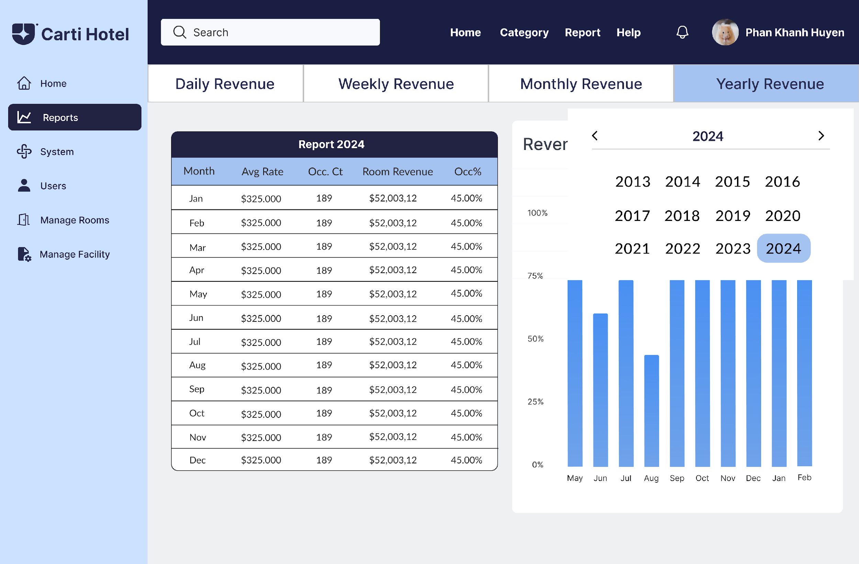

The resulting report is displayed as a table containing monthly details for the chosen year, accompanied by a column chart for visualization.

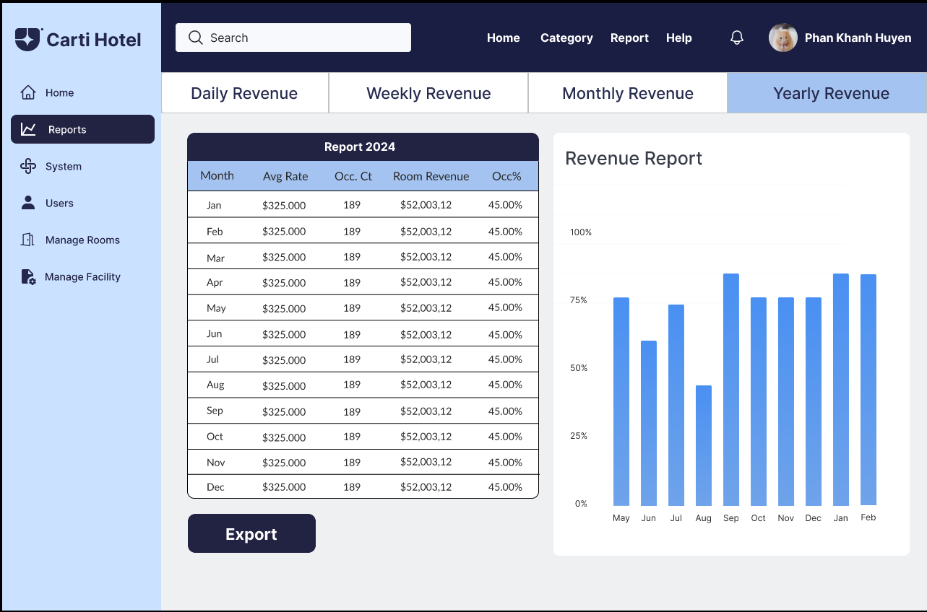

Clicking on "Export" enables the admin to export the data in Excel format.